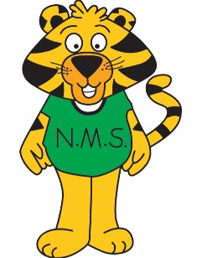Nashwaaksis Memorial Elementary School
Grade 5 School Supply list

All supplies and student fee are due on the first day of school.

Our student fee for 2021/2020 will be $50 which will cover most school supplies.
Payment is preferred via cashless schools but can also by paid by cash or cheque made payable to Nashwaaksis Memorial Elementary School.

Students will also need to bring the following items:

- Book bag
- Lunch Bag
- Water bottle (spill and break proof)
- Headphones or earbuds
- 2 boxes of Kleenex
- 1 box of large and medium freezer bags
- 1 pair of sharp scissors
- Indoor sneakers

