June 2018

It is with mixed emotions that we inform you that Carol Daine is retiring this month. Carol has devoted her entire career to Nashwaaksis Memorial School. She will be truly missed by her colleagues, students and their parents. We wish her good luck with her future plans!

We are sending a reminder that the On-Line Registration site for the Grade 1, 3 and 6 French Immersion Entry Points will close June 29th.

Many of the classes are going on educational field trips this month. Make sure to find out from your child’s teacher, what is happening with your child’s classroom!

Family Fun Night was a huge success! A special thanks to the Nashmore Parents Association for all of their preparation, set up and efforts and to the NMS staff for running the activities.

With the recent summertime weather that we have been experiencing, our staff has noticed more and more students wearing flip-flops and sandals to school. Although this type of footwear is comfortable and appropriate for the summer months, they do represent a safety issue for our students during school hours (students often trip or lose this footwear off their feet while walking up the stairs or playing on our playground during recess and Physical Education). In order to avoid this, please ensure that your children come to school with outdoor sneakers.

Science, Social Studies and Health clusters are taking place each Friday of this month.

June 13th is our school’s Bilingual fair.

June 14th the Drama Club will be performing for the public at 5:00pm at the local outdoor theatre.

June 15th is Sunglasses Day.

June 19th the Public Library will be presenting their summer program to the students.

June 20th is our school Talent Show. The Talent Show for our students only. We ask that parents do not attend. Thank you for understanding.

The Grade 5 Celebration is June 21nd at 1:00 pm. Grade 5 parents, guardians and extended family are welcome.

June 22nd schools will be dismissed at 11:30 am.

Due to our transient and growing school population, we are unable to tell you which class your child will be in next year. Believe it or not, the lists change right up until the first day of school and sometimes even after that. Please do not call the week before school as we are unable to tell you which class your child is in. We empathize with you and your child’s anxiety and excitement but disappointment is worse when the class lists change. Thank you for understanding. ☺

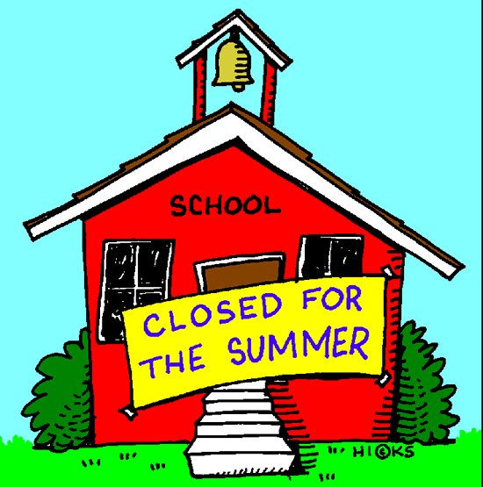

Have a safe and active summer!!

