May 2018

The grade three classes are participating in Books for Bikes event sponsored by the Alexandria Lodge #33. For every book read or every 20 minutes read, the children can enter a ballot to win a brand new bicycle. There will be two bicycle draws per class, a total of 6 new bicycles for 6 of our students!

Below is a neat website to help all parents know what to look out for:

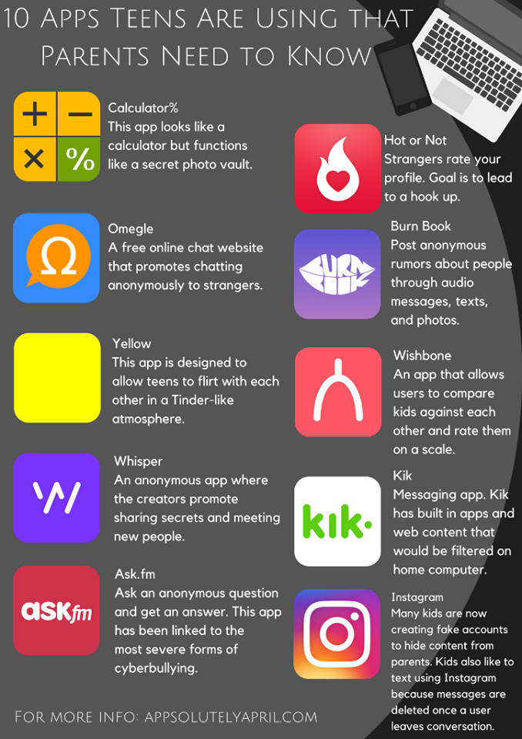

https://appsolutelyapril.com/2018/03/21/10-apps-teens-are-using-that-parents-need-to-know/

Thank you to the volunteers who helped to run the Book Fair and to the parents for allowing the children to buy! Our school was able to get $722 worth of free books school library received close to $700 to spend on books in the future.

Our school was also very fortunate to be a part of First Books Canada where we received 300 books for children to use in the classroom and take home to keep. The books will be coming home in the next few weeks.

Friday, May 4th – no school - Subject Council Day and staff professional learning.

Popcorn Day is scheduled for May 11.

Monday, May 14th – no school – NBTA Day.

Tuesday, May 15th is our PSSC meeting.

Monday, May 21st – no school - Victoria Day.

Grade 2 and Grade 4 Provincial Assessments are during the weeks of May 22 – June 1.

Wednesday, May 23rd at 1:30 pm is the Kindergarten Orientation Meeting for next September’s Kindergarten students.

Thursday, May 24th is our grade 3-5 Track and Field try-outs, with a rain date of the 28th.

Tuesday, May 29th is an early dismissal at 11:30 am for staff professional learning.

Thursday, May 31st is School Hat Day.

The grade 5’s are involved in a tour of Nashwaaksis Middle School on the 31st of May at 9:00 am.

