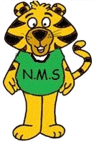
NASHWAAKSIS MEMORIAL SCHOOL
80 Main Street
Fredericton, NB E3A 1C4
Telephone: (506) 453-5421
Fax: (506) 453-3942
Website: nms.nbed.nb.ca

Mr. Jason Burns Mr. Alex Yaychuk
Principal Vice-Principal

June, 2021

In September, we will be collecting $50.00 from each child and the teachers will purchase the school supplies. You will be able to pay this through School Cash Online as of August 1, 2021.

You are only responsible to purchase a pair of indoor sneakers, a back pack, a lunch bag, and 2 boxes of Kleenex. Sneakers, back pack, lunch bag and Kleenex all need to be brought to school on the first day. If you are not paying the $50 online, it is due the first day of school.

Have a safe and happy summer! We look forward to seeing you in September!

Nashwaaksis Memorial Grade 3 FI Teachers


