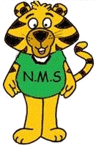
NASHWAAKSIS MEMORIAL SCHOOL
80 Main Street
Fredericton, NB E3A 1C4
Telephone: (506) 453-5421
Fax: (506) 453-3942
Website: nms.nbed.nb.ca

Mr. Jason Burns Mrs. Christie Jordan
Principal Vice-Principal

June, 2022

In September, we will be collecting $50.00 from each child and the teachers will purchase the school supplies. You will be able to pay this through School Cash Online as of August 1, 2022.

You are only responsible to purchase a pair of indoor sneakers, a back pack, a lunch bag, 2 boxes of Kleenex, ear buds/ear phones and a luggage tag with bussing/drop off & pickup information filled in.

Sneakers, back pack, lunch bag, Kleenex, ear buds/ear phones and luggage tag all need to be brought to school on the first day. If you are not paying the $50 online, it is due the first day of school.

All students will receive an NMS water bottle in September!
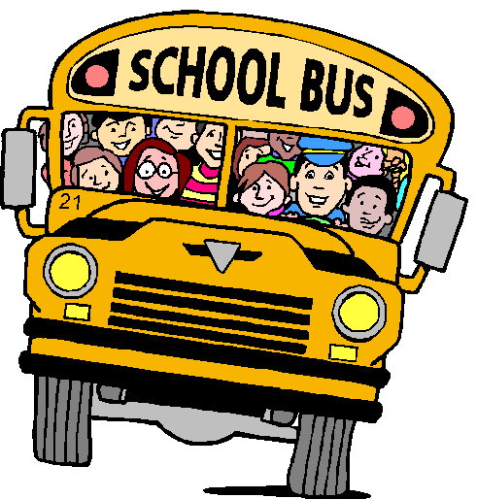
Have a safe and happy summer! We look forward to seeing
you in September.

Nashwaaksis Memorial Grades 3 – 5 Teachers

