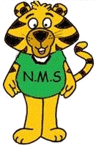
NASHWAAKSIS MEMORIAL SCHOOL
80 Main Street
Fredericton, NB E3A 1C4
Telephone: (506) 453-5421
Fax: (506) 453-3942
Website: nms.nbed.nb.ca

Mrs. Jackie Hay Mr. Alex Yaychuk
Principal Vice-Principal

June, 2018

In September, we will be collecting $40.00 from each child and the teachers will purchase the school supplies. You will be able to pay this through School Cash Online as of September 1, 2018.

You are only responsible to purchase a pair of indoor sneakers, a back pack, a lunch bag, and 2 boxes of Kleenex. Sneakers, back pack, lunch bag and Kleenex all need to be brought to school on the first day. If you are not paying the $40 online, it is due the first day.

Have a safe and happy summer! We look forward to seeing you in September!

Nashwaaksis Memorial Teachers
