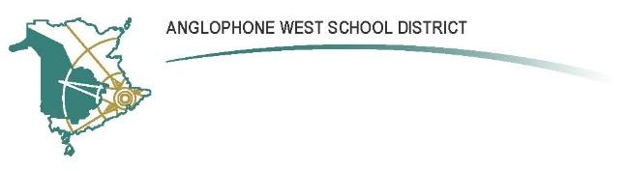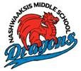
Nashwaaksis Middle School
324 Fulton Avenue, Fredericton NB E3A 5J4
PARENT SCHOOL SUPPORT COMMITTEE
MINUTES
Date: October 3, 2017 Time: 6:30-8:00pm
Location: Nashwaasksis Middle School
PSSC Members Present:  - Jonathan Keizer  - Carolin Galvin  - Jennifer Welles  - Keri Clark  - Melissa Durling  - Susan Nicol  PSSC Members Regrets:  - Tiffany Bastin  - Frances Lipsett  - Jeanne Sayre  - Kim Hamilton | School/DEC Representation Present:  - Kendra Frizzell, Principal  - Sean Winslow, DEC  - John Hickey, Teacher representative  School/DEC Representation Regrets:

Call to Order:
18h30
Welcome and Introductions
Principal Kendra Frizzell welcomed new and returning members.
Roles
Tiffany Bastin has stepped down as PSSC chair. Kendra requested nominations for chair and vice-chair.
Motion:
It was moved that Jennifer Welles be nominated as chair of the NMS PSSC.
Motion carried by consensus.
Motion:
It was moved that Jonathon Keizer be nominated as vice chair of the NMS PSSC.
Motion carried by consensus.
Approval of Agenda:
A copy of the agenda was circulated to members for review and was approved by consensus without changes.
Meeting Minutes:
Carolin Galvin will prepare minutes for 2017-18 PSSC meetings. Minutes will be prepared using the Anglophone West School District Education Council template. Minutes will be circulated to members after each meeting for review and approval.
Business Arising from the Minutes:
Principal’s Report
- School Improvement Plan – The NMS teacher leadership team has produced a working copy of the NMS School Improvement Plan . An overview of the plan was provided along with plans for the current year.

New Business:
Meeting Schedule
PSSC meeting times were set for 18h30 to 20h00, on the second Tuesday of each month. A minimum of 6 meetings will be held (Nov. 14, Dec. 12, Jan. 9, Feb. 13, Mar. 12, Apr. 10).
Meeting Norms
- No personal information will be discussed with respect to students, teachers or community members;
- Meetings will start and finish on time.
Friends of NMS
- Parent groups responsible for fundraising, volunteering and organizing student activities.
- Chair of Friends of NMS, currently Kim Hamilton, will regularly share updates with the PSSC on behalf of Friends of NMS.
School Improvement Plan
- NMS has a 3-year plan to build a school improvement plan, which began in the 2016-17 school year. Year 1 (2016-17) goals include:
  - Student engagement in the classroom and in extra-curricular activities; teacher engagement in extra-curricular activities and in continuing education;
  - Formative assessment practices
  - Build collaborative leadership capacity – a leadership team has been established including 12 staff members.
Year 2 (2017-18) goals include:
  - Further development of above objectives
PSSC Orientation
- New members were directed to the online PSSC Handbook at http://web1.nbed.nb.ca/sites/ASD-W/PSSC/Documents/PSSC%20Handbook.pdf .
- An upcoming PSSC orientation session is being held at Bliss Carman Middle School for members who wish to attend.

Joint PSSC
- A joint PSSC was initiated last year. Principals of feeder schools were invited to attend an NMS PSSC meeting. Subsequently, two NMS teachers spend the day at Park Street School to exchange best practices. Although the intention was to visit other feeder schools, an obstacle presented itself: NMS is part of the OAC (Oromocto) and the feeder schools are part of the FAC (Fredericton), each with different budget authorities.
- Feeder school principals will once again be invited to attend an NMS PSSC meeting in 2017-18.
- Future goals include: (1) Continue NMS and feeder school principal collaboration, and (2) LHHS collaboration.

Correspondence:
None noted.
Closing Comments:
None noted.
Date of next meeting:
Tuesday, November 14, 2017
Adjournment:
20h00

____________________ ____________________
PSSC Chair Date

____________________ ______________________
PSSC Secretary Date

