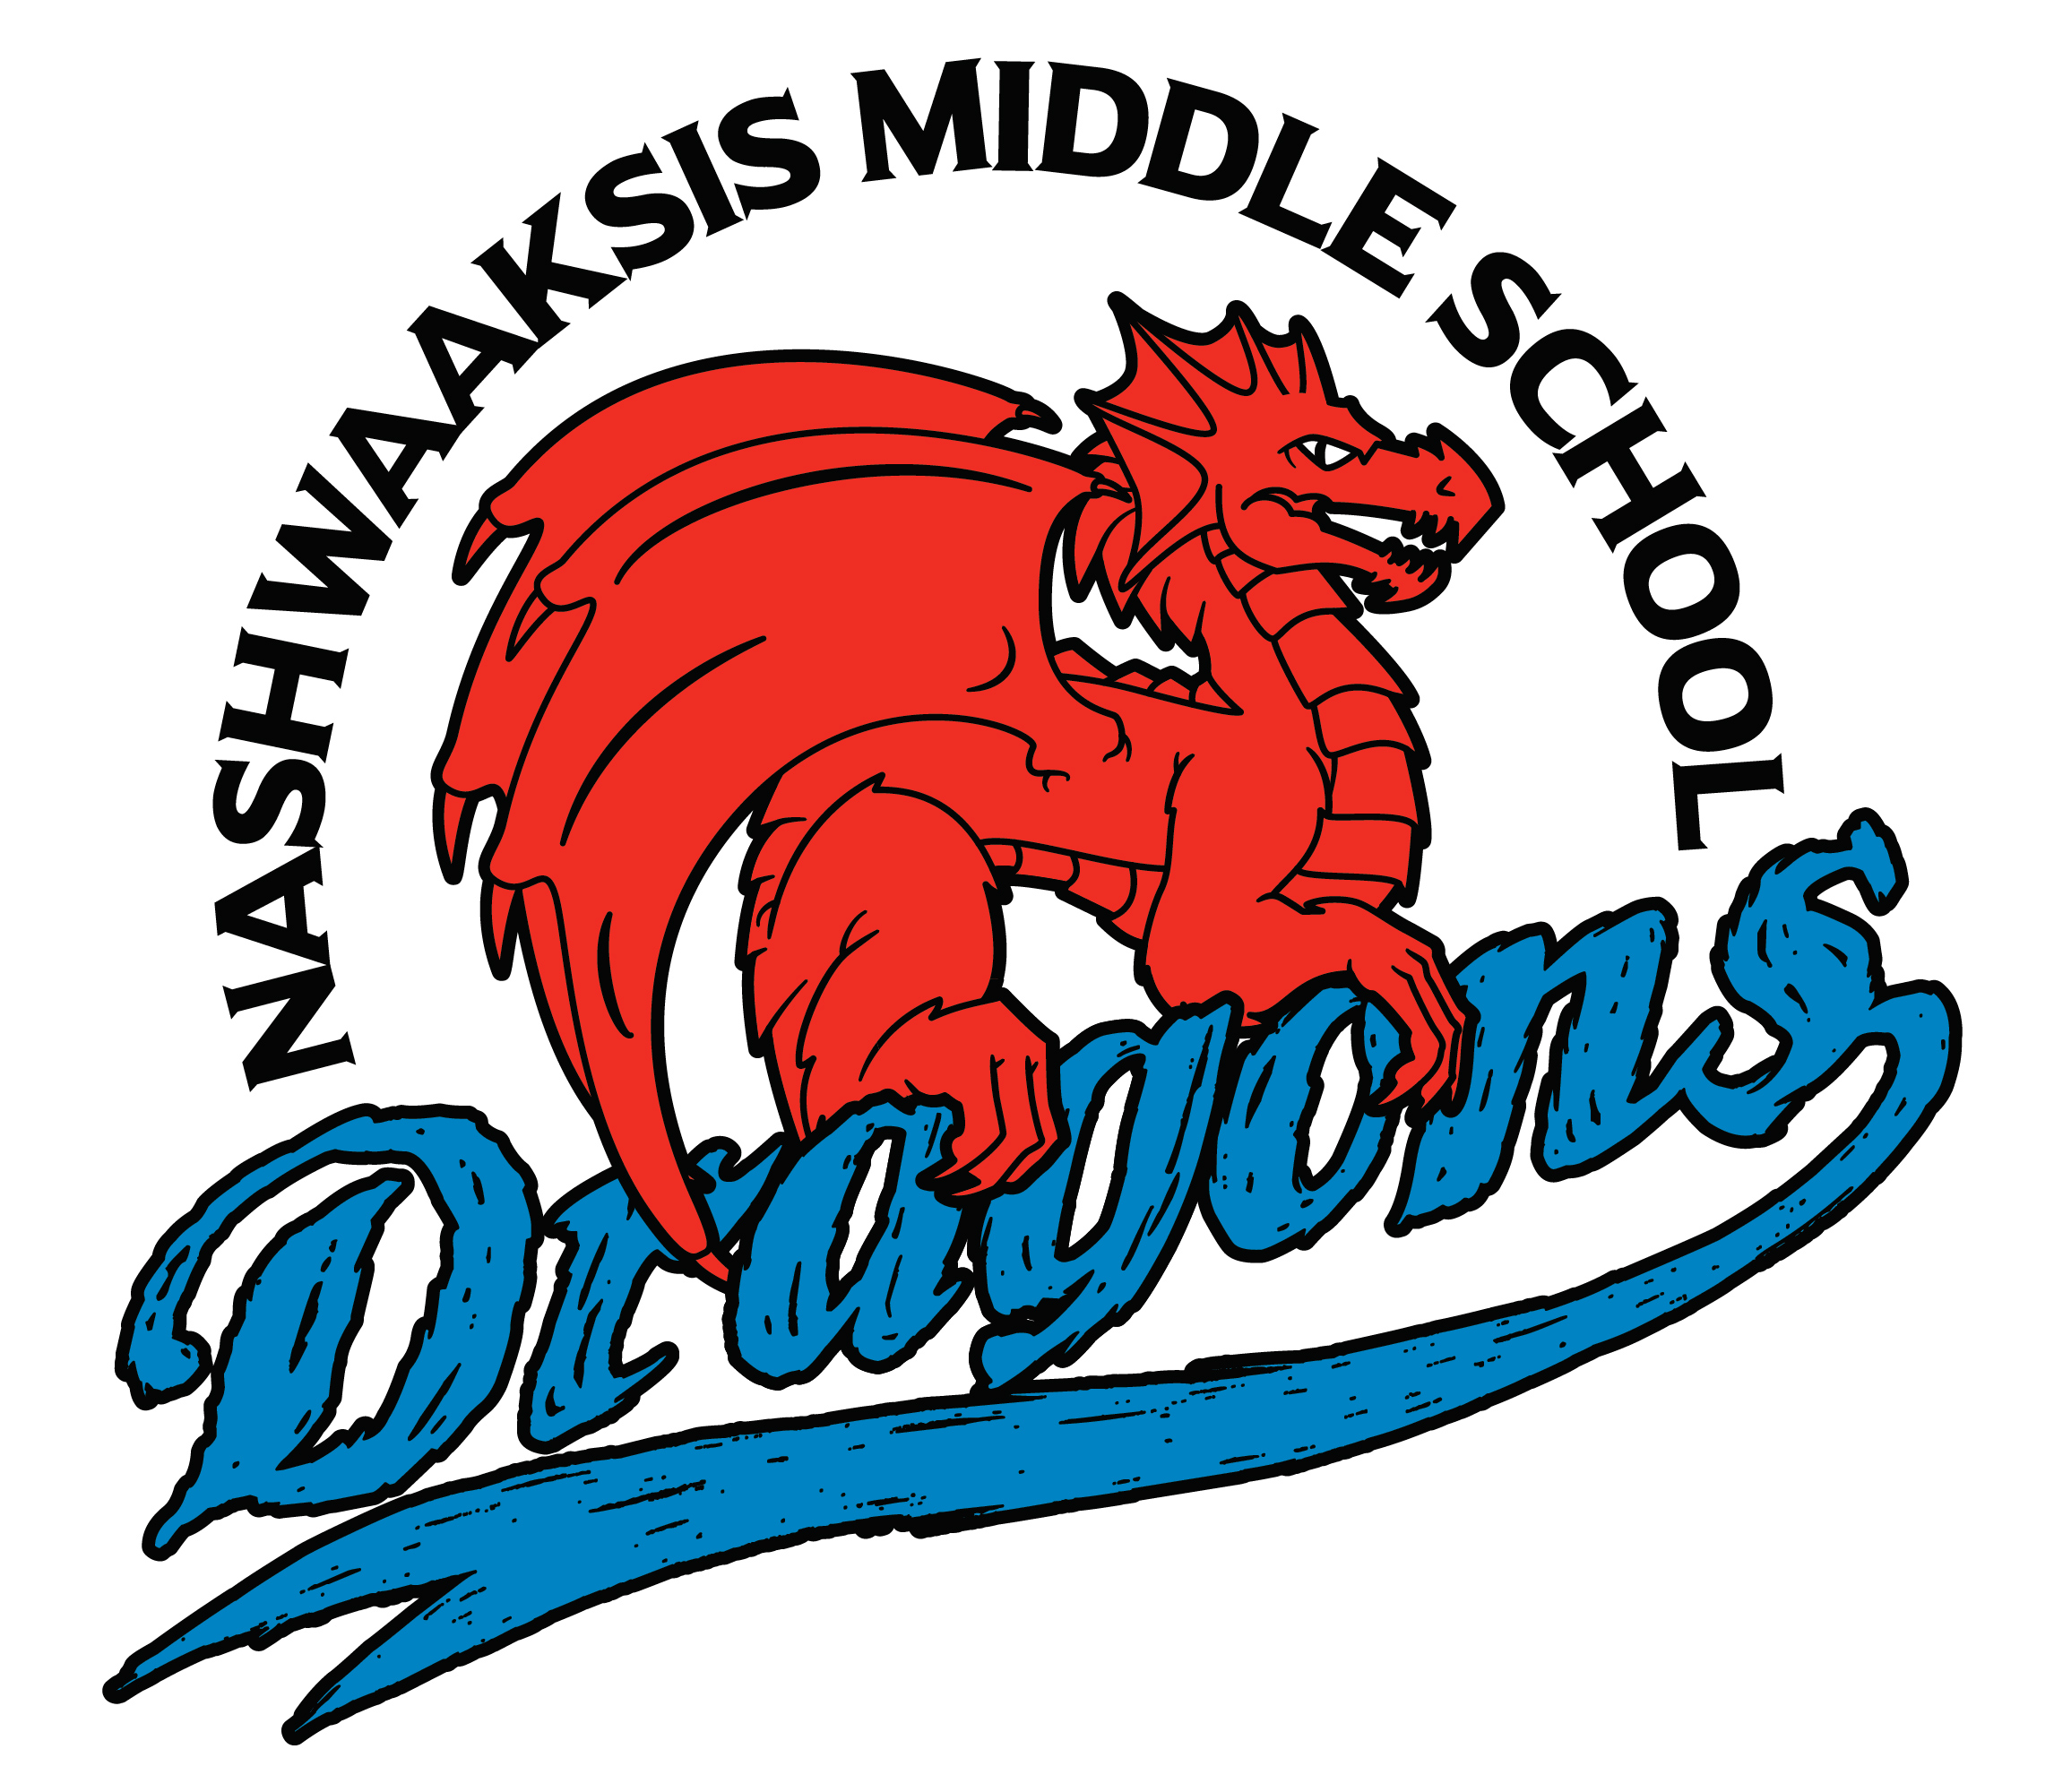

Nashwaaksis Middle School
324 Fulton Avenue, Fredericton, NB
E3A 5J4

Principal Vice Principal
Kendra Frizzell Marcie Connors

On behalf of all the Staff and Grade 8 Students at Nashwaaksis Middle School we want to Thank our generous Sponsors for thier donations and support for our Grade 8 Celebration 2019.
With the help of your generous donations, our Grade 8 Celebration will be a great success. We could not have done this without your awesome Sponsorship and Community support.
The Students also, would like to thank, all the parent volunteers who have spend many nights and weekends planning and organizing the special day of fun activities and a very special night to celebrate their years here at NMS.
thank you, thank you, thank you...
- Blueridge
- Atlantic Superstore
- Victory Meat Market
- Mama’s Pub
- City of Fredericton
- Pizza Hut
- Kwik Kopy
- Danny Gill
- CIBC Wood Gundy
- Mike Sorenson – Nashwaakvalley farm
- Key Elements Media
- Amy Watt - The Right Choice Realty
- Tyler Zinks
- Brian Stewart
- And of course many many parents

Yours Truly
The NMS Class of 2019

