**BRIEF DESCRIPTION**

The **Strengthening Families Program** (SFP) is an internationally recognized evidence-based relationship building program that engages youth aged 12 to 20 years of age, and their families in 14 family training sessions using family systems and cognitive behavioral approaches to increase resilience and reduce risk factors. It seeks to improve family relationships, parenting skills, and youth’s social and life skills.

**HOW IT WORKS**

The SFP curriculum is a 14-session behavioral skills training program of 3 hours each.

**Hour 1**: **Family Meal** (provided by the JHSF)

* Building relationships between participants and trainers; modeling pro-social family practices; debriefing; and discussion based learning

**Hour 2**: **Training Sessions**

* Parents meet separately with two group leaders to learn how to improve desired behaviors in youth by increasing attention and rewards for positive behaviors. The also learn practices related to clear communication, effective discipline, substance use, problem solving and limit setting.
* Youth meet separately with two group leaders to learn how to understand feelings, control their anger, resist peer pressure, comply with parental rules, solve problems, and communicate effectively. Youth also develop social skills and learn about consequences of substance abuse.

**Hour 3: Practice Session**

* Structured family activities, practice therapeutic play/interaction, conduct family meetings, learn communication skills, practice effective, discipline, reinforce positive behaviors in each other, and plan family activities.

**Booster sessions** and ongoing family support groups for SFP graduates increase generalization and the use of skills learned. Two booster sessions are provided at 6 month intervals following completion of the core training.

**Program Incentives & Supports**

* Childcare is provided onsite for younger siblings (under the age of 12)
* Family Meal Provided Weekly
* Transportation stipend is available: $10/week
* Completion Incentives: $50/family
* Booster Session Participation Incentives: $25/family for each of the two Booster Sessions

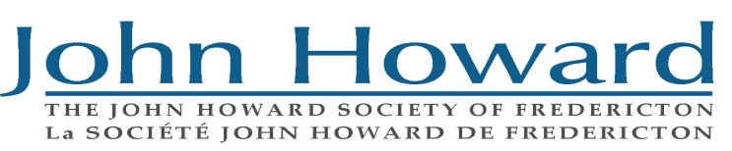**Picture10**

|  |  |  |
| --- | --- | --- |
|  | **PROTECTIVE FACTORS** | **RISK FACTORS** |
| **Individual** | • Self-esteem  • Social and life skills  • Resistance to negative peer ..influences | • Depression  • Conduct disorders  • Aggression, violence, delinquency  • Shyness and loneliness |
| **Family** | • Parenting efficacy  • Family organization  • Effective communication  • Parent-child attachment  • Parental mental health | • Family conflict  • Excessive punishment  • Child abuse and/or neglect  • Ineffective discipline  • Modeling of substance use by family  members  • Family alcohol or drug abuse  • Differential acculturation |
| **Peer** | • Pro-social friendships  • Effective communication | • Substance-using friends  • Negative peer influence |
| **School** | • Grades  • School bonding | • Tardiness  • Times absent  • Lack of school bonding |

|  |  |
| --- | --- |
| **Program Time and Dates**  Monday evenings: 5:30 – 8:30 | |
| 14 weeks | Start date to be determined |