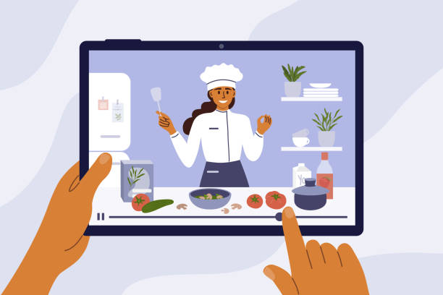  - Nov – Dec 2020  NMS maker challenge cooking show  Get a team, prepare a proposal, and make it happen!  Teams of students will write, produce, direct and star in their very own cooking show. Teams will be required to submit a script as well as ingredient and equipment list prior to their video session. Recipes must be nutritious, delicious and be able to be frozen. Once your plan is submitted you will be able to book a timed session in the school kitchen to prepare, cook and shoot your cooking show.  One student could complete more than one role. Some possible roles for your team:  - The prep and cooking roles including Head Chef, Sous Chef, Prep Cook and clean up crew. Some of these will be on screen and some may not be on camera.  - The tech roles such as camera person, editor, director  - Teams will be expected to follow Covid safety procedures as outlined in the school’s operational plan for the kitchen. | Calling all home chefs! Enrichment opportunity!  ____  Create teams of no more than 5. All team members must be from the same class bubble. Must follow Covid safety procedures.  ____  Food that is made for the show will be distributed to students via the Breakfast Program.  ____  Shows will be posted to TEAMS for student viewing.  Due date for Team proposals  November 27th, 2020  Due date for cooking show video  December 18th, 2020

  - Nov – Dec 2020

NMS maker challenge cooking show

Step 1
Create a team. Teams are a maximum of 5 students, all of whom must be from the same class bubble. All team members must also be in good standing with teachers both behaviorally and academically.

Step 2
Discuss and assign roles to team members. Make sure to be clear about roles and responsibilities.

Step 3
Work on the details so you can prepare a proposal. You need a recipe, ingredient list and a list of equipment required for your final product. You do NOT need to purchase any ingredients or materials; the school will provide these items. Your recipe must be nutritious and delicious. Most importantly it must be a recipe that can be easily frozen and thawed because it will be distributed to students through the breakfast program. NMS is a nut free building.

Step 4
Write your script and finalize your proposal. Please see the next page for an example of a proposal.

Step 5
Submit your proposal. Next you will be contacted by C. Brophy or C. Birney about booking a time in the kitchen.

Step 6
Once you have a date a time scheduled your teams needs to ensure you are all ready for your showtime! When you arrive for your showtime, your ingredients and equipment will be waiting for you in the kitchen. An Ipad will be available for you to use to film your show! You will also be required to review the school’s operational plan for the kitchen which will detail all Covid protocols your team will be expected to follow.

Step 7
Shoot the show! Edit your show! Make it awesome and when you are finished, submit the final show through the TEAMS app. You will be invited to join the Maker Team once your proposal is approved.

Step 8
Once all teams have completed and uploaded their shows, they will be made available to the whole school to watch. Judging will commence!

What does a proposal look like?

Cooking Show Proposal

Team member and roles:
- Minnie Mouse – head chef and editor, clean up crew
- Mikey Mouse – sous chef and clean up crew
- Daffy Duck – camera person, clean up crew

Recipe name: Banana muffins

Ingredient list: (list amount and item)
- 1½ cup of flour
- 2 ripe bananas
- 2 eggs
- 1 tsp baking soda
- ¾ cups white sugar

Equipment list: (list amount and items)
- 2 mixing bowls
- 1 masher to mash bananas
- 2 spoons
- 2 muffin tins – 24 muffins each

Procedural script:
- In this section you would write the specific steps you will follow to make your recipe. You should include tips on how to make it extra good such as do not overmix or if you want you could add chocolate chips.
- You will also plan camera angles and close ups of food preparation if needed.

**Your proposal can be submitted hand written on loose leaf or typed up and emailed to casey.brophy@nbed.nb.ca **

**You must use the headings that are in the example above: Team members, ingredient list, equipment list and procedural script.

