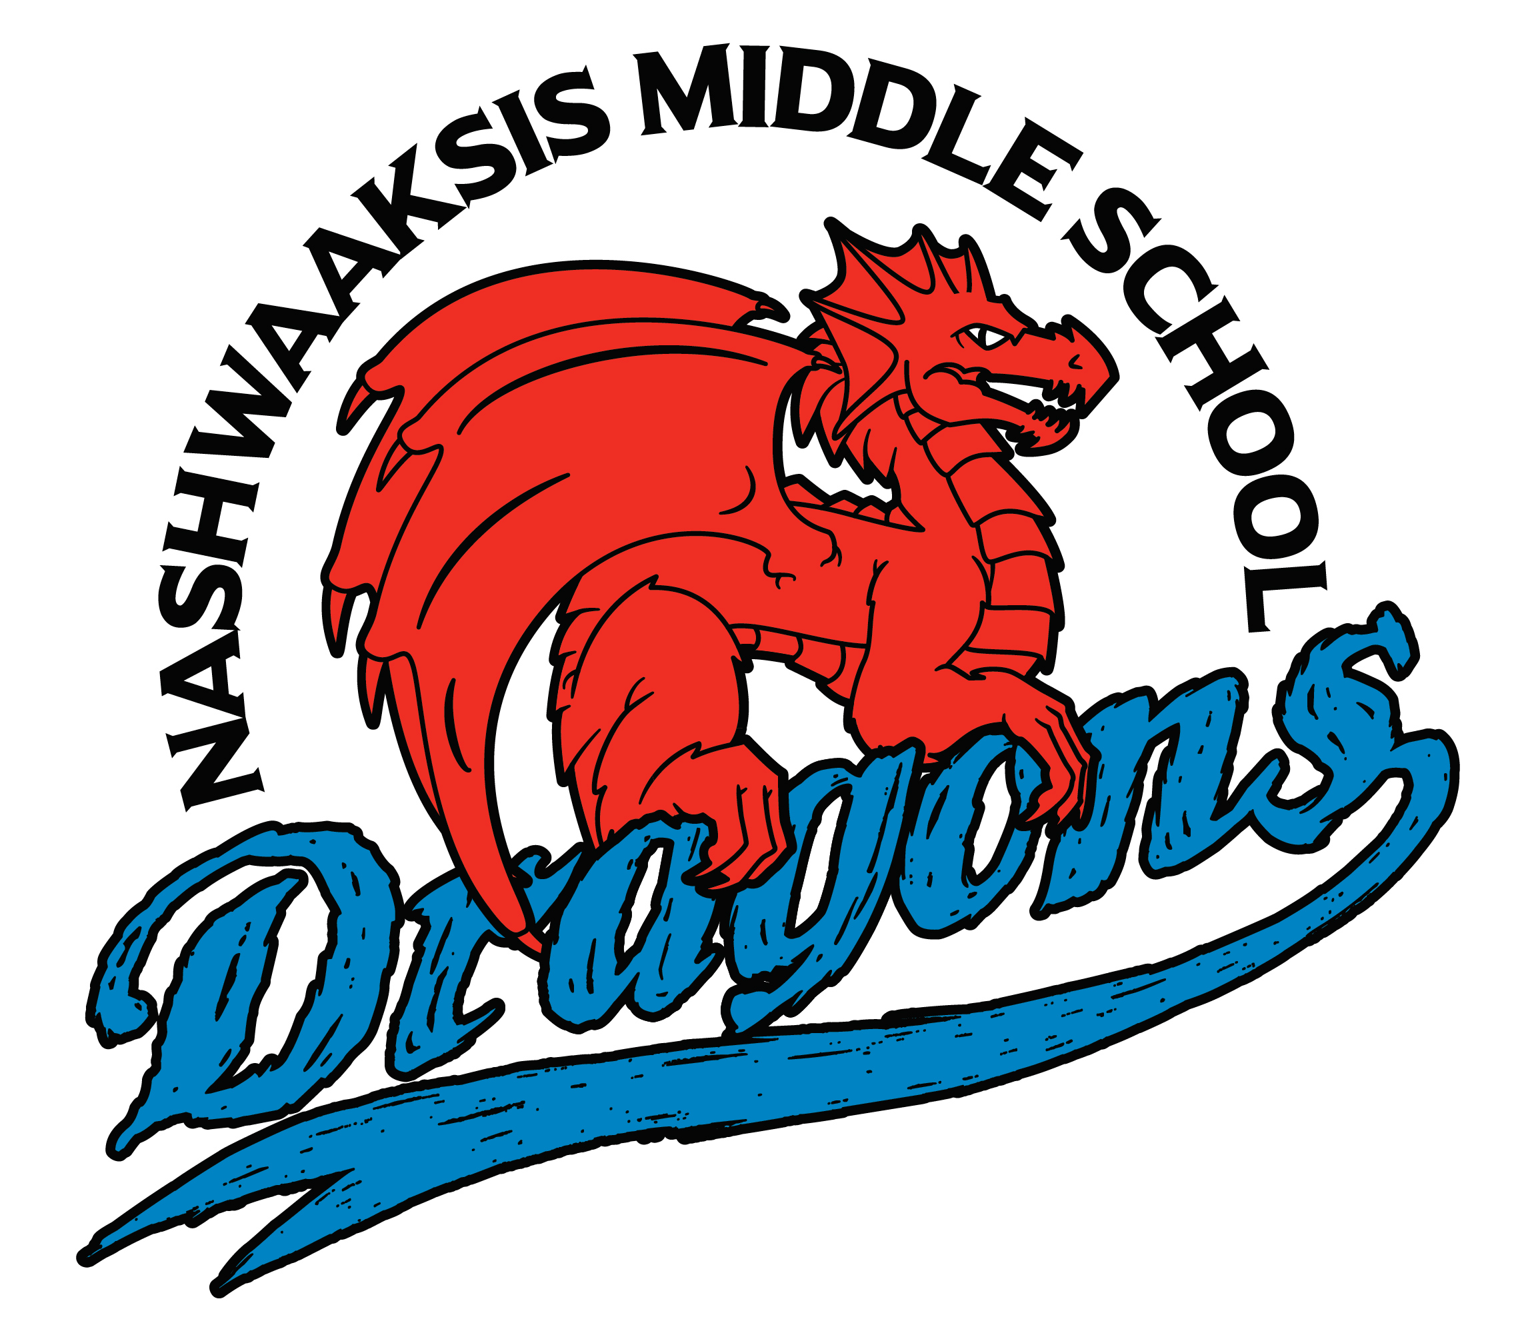

Nashwaaksis Middle School
324 Fulton Avenue, Fredericton, NB E3A 5J4
Phone:(506) 453-5436 Fax:(506) 444-4129

Principal Vice Principal
Kendra Frizzell Marcie Connors
Dear Parents/Guardians:

We are pleased to inform you that we are continuing to make progress with our new Personal Wellness Curriculum. The curriculum consists of four strands found in the attachment included in this email.

Keeping children safe and healthy is of great importance to both parents and educators. Healthy students are more productive students and are more likely to grow up to be healthy, happy adults. The intent of the curriculum is to assist and support parents in teaching their children knowledge and skills to promote personal wellness. All the information is developmentally appropriate for children and builds on what they have learned in previous grades. The curriculum supports the development of skills to make healthy choices.

The Growth and Development strand of the curriculum is based on three surveys involving parents, teachers and students across the province. Over 4200 parents, more than 330 teachers and in excess of 2400 students provided feedback on a variety of sexual health issues. The final document represents, in a measured manner, the essential elements that were asked for by all three groups. The Growth and Development strand of the New Brunswick Personal Wellness document(s) emphasizes that abstinence from all sexual activity that involves risk is the best and only truly safe health choice for adolescents. Students who do decide to become sexually active now or in the future need information about the effective use of protection against pregnancy and sexually transmitted infections. Classes do not encourage students to become sexually active nor do they include teaching about sexual techniques.

We encourage you to talk with your children about what they are learning in Health and to contact the school if you need further information. Your interest and support are greatly appreciated.

Sincerely,
Mr. Ouellette

____________________________________________________________________________________________

If you DO NOT wish to have your child participate in the Growth and Development strand, or a particular part of it, then please respond to this email indicating the following:

I do not wish for my child (name) ____________________ to take the Growth and Development strand of the Personal Wellness Curriculum. I request that alternative arrangements be made.

