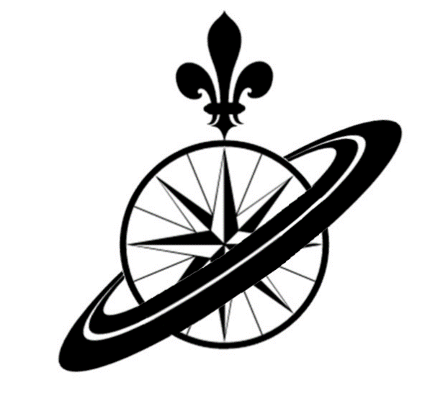
Grade 6 Quebec Space Camp
May 18-21, 2017-2018

Just a quick reminder that there is a 30-40 minute information meeting this Wednesday, January 10th and Friday, January 12th at 6:30 in the Nashwaaksis Middle School Theatre. I have booked two dates in case of weather and to accommodate your schedule. Attendance at only one of the two meetings is necessary. Please also bring the completed application form to this meeting.
See you there!

