Muscle of the Week - Biceps
This week we are looking at the bicep muscle, which is the most common muscle thought of when someone flex’s to show off their strength. As seen in the picture below, the Bicep is made of two muscles which work together to move your lower arm towards your shoulder. The muscle is attached to bone by muscle tendons. If you hold your arms straight out, “proximal” tendons are the tendons which are closest to your shoulder, and the distal tendon is the tendon which is furthest from your body near your elbow. These tendons are needed for the muscles ability to move your arm. When the muscle contracts, your arm moves towards your shoulder and when it relaxes it extends your arm away from your shoulder.

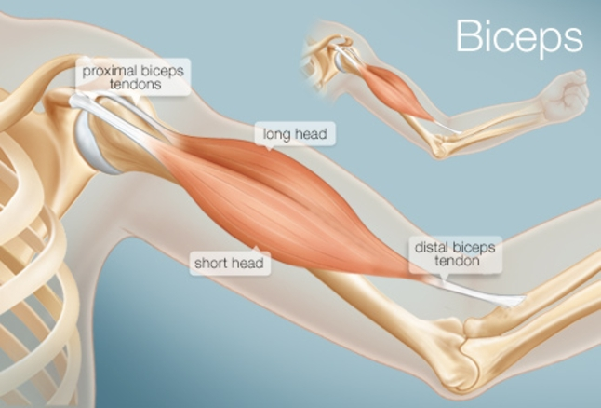
Stretching: You can stretch your bicep muscle by holding your arm straight in front of your body, rotating your hand so your palm is supinated (palm facing the ceiling or sky) and pulling your fingers down to the ground with your other hand.
Strengthening: You can strengthen your bicep muscles, by performing a bicep curl. Holding a weight (water bottle) in your hand, pull your lower arm up to your shoulder. Keep your back straight and maintain steady breathing. The more repetitions (number of times you perform the curl) you do, the more your muscle will have to work. Over time this will strengthen your muscle. If you are doing an exercise with just one arm, be sure to repeat the exercise with the other arm.
Does the angle of your hand holding the weight effect how your bicep feels?
Do you notice any change in how your muscles feels after many repetitions?

