Muscle of the Week - Triceps
This week we are looking at the Triceps muscles, which are located on the backside of your upper arm. On the front we had our biceps and on the back we have our triceps. The triceps are made up of three different muscles which work together to straighten your arm at the elbow. The three different muscles which make up the triceps are the long head, medial head and lateral head. The triceps muscle is used commonly in pushing movements, such as pushups.
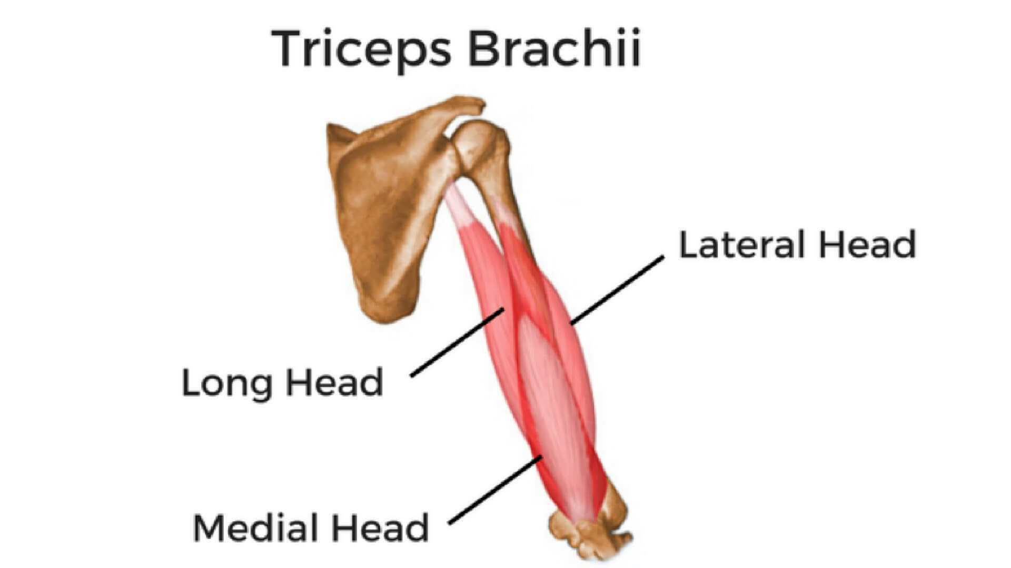

Stretching: An easy stretch for the triceps muscle is done by reaching your hand over your head, then reaching down the middle of your back with your hand. Using your opposite hand, you can pull lightly on the elbow above your head to increase the tension on your stretch. When stretching, it should not be painful and the stretch should be held for a minimum of 10 seconds. If you stretch one arm, be sure to always perform the same stretch on the other arm.

Strengthening: When strengthening the triceps there are many exercises you can do. The most common triceps exercise is a pushup with your hands on the floor directly in front of your shoulders. Doing your best to keep your elbows by your sides and keeping your body in a flat “plank” position (lifting your body so that only your hands and feet are on the floor), lower your body then push back up. This may be difficult if never done before, so you can always try the same motion from your knees instead of your feet.

