Muscle of the Week – Hamstring Muscles
This week we are looking at the hamstring muscles which are located on the back of your legs above your knee. The Hamstrings, similar to the quadriceps, are important for activities such as walking, running and jumping. There are three long muscles which make up the hamstring muscles. These muscles work together to bend our knee, moving our heel to our bum if standing. They also help move the leg backwards from your hip when walking, running, or doing other activities.
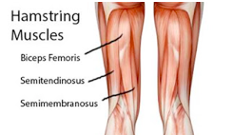
Stretching:
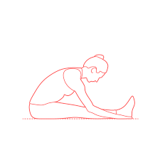
It is important to stretch both the quadriceps and hamstrings for general health. An easy hamstring stretch you can do is a seated stretch with both legs out in front of your body. With both feet together, heels on the ground and straight legs, lean your body forward and reach to your toes. Hold a comfortable stretch without straining yourself. You will find that some people can stretch their hamstrings much further than others.

Strengthening:
Strengthening the hamstring muscles can be done in many different ways. Maintaining a physically active lifestyle is the easiest way to keep your hamstring muscles strong. If you wish to further strengthen your hamstring muscles doing lounges, squats, jumping, or sprinting will all help to strengthen your hamstrings.

