Muscle of the Week – Calf Muscles
This week we are looking at the calf muscles which are located on the back of your lower leg below your knee. The calf muscles are made up of two large muscles and a large tendon. The Achilles tendon attaches the muscles to our heel bone located at the back of your foot. These muscles work together to pull our heel up, which makes our toes push down. So if you are seated and you push your toes down, your heel will lift off the floor from the use of your calf muscles.
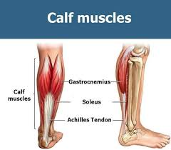
Stretching:
Stretching the calf muscle can be done in many ways. An easy way to stretch your calf is to face the wall and push against the wall with both hands. Moving one foot back, set that back foot flat on the ground and lean your body forward. If you are not feeling a stretch you need to move your foot back more and ensure that your heel stays on the ground for a proper stretch.
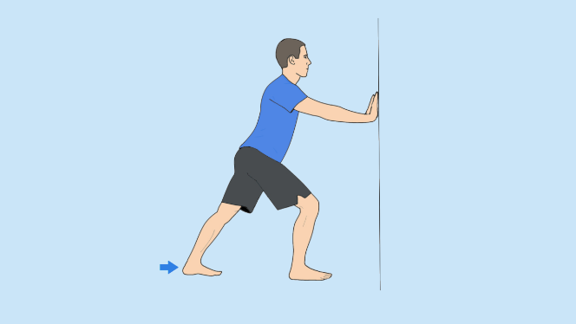
Strengthening:
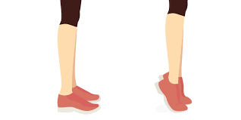
Strengthening the calf muscles can be done in many different ways. Maintaining a physically active lifestyle is the easiest way to keep your calf muscles strong. If you wish to further strengthen your hamstring muscles doing jumping, running or sprinting will help to strengthen your calf muscles. You can also do an exercise called a “calf raise” where you stand still on the floor and simply raise up onto your toes and hold for about a second, then come back to a stand. This movement can be repeated for further strengthening.

