Muscle of the Week - Pectoral
This week we are looking at the pectoral (pec) muscles, which are at the front of your body beside your deltoids. There are two pectoral muscles, the pectoralis major and pectoralis minor. The pectoralis major is the larger muscle of the two and is located above the pectoralis minor. The Pectoralis minor is much smaller and has a different shape compared to the pectoralis major. It is located beneath the pectoralis major and therefore you cannot see this muscle on your body.
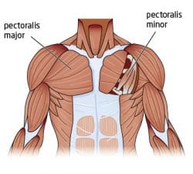
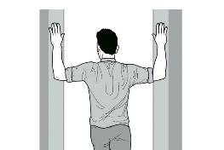
Stretching: The Pectoral muscles can be difficult to stretch due to where they are located on the body. One of the most common pectoral stretches will also stretch the deltoid. Using an entryway of some kind, put your hand and elbow on the wall and move your body forward to draw your arm back. Your elbow should be at the same height as your shoulder. Being careful to not push too hard, move your body until you feel a stretch.

Strengthening: When strengthening the pectorals there are many exercises you can do. One of the easiest and most common exercises is a pushup with your hands on the floor outside of your shoulders. When working your pectorals you do not need to try and keep your elbows by your side, rather just off of your side and keeping your body in a flat “plank” position (lifting your body so that only your hands and feet are on the floor), lower your body then push back up. This may be difficult if never done before, so you can always try the same motion from your knees instead of your feet.

