Muscle of the Week – Latissimus Dorsi
This week we are looking at the Latissimus Dorsi Muscle. This muscle is located on your back and is the largest muscle on your upper body! The Latissimus Dorsi is also known as the “lats”. These muscles are very large but quite flat and shaped like a triangle. The muscle attaches to many different areas along the back and also the upper arm bone (the humorous). This allows the muscle to affect our shoulder movements, and any twisting movements from our shoulder to hips.
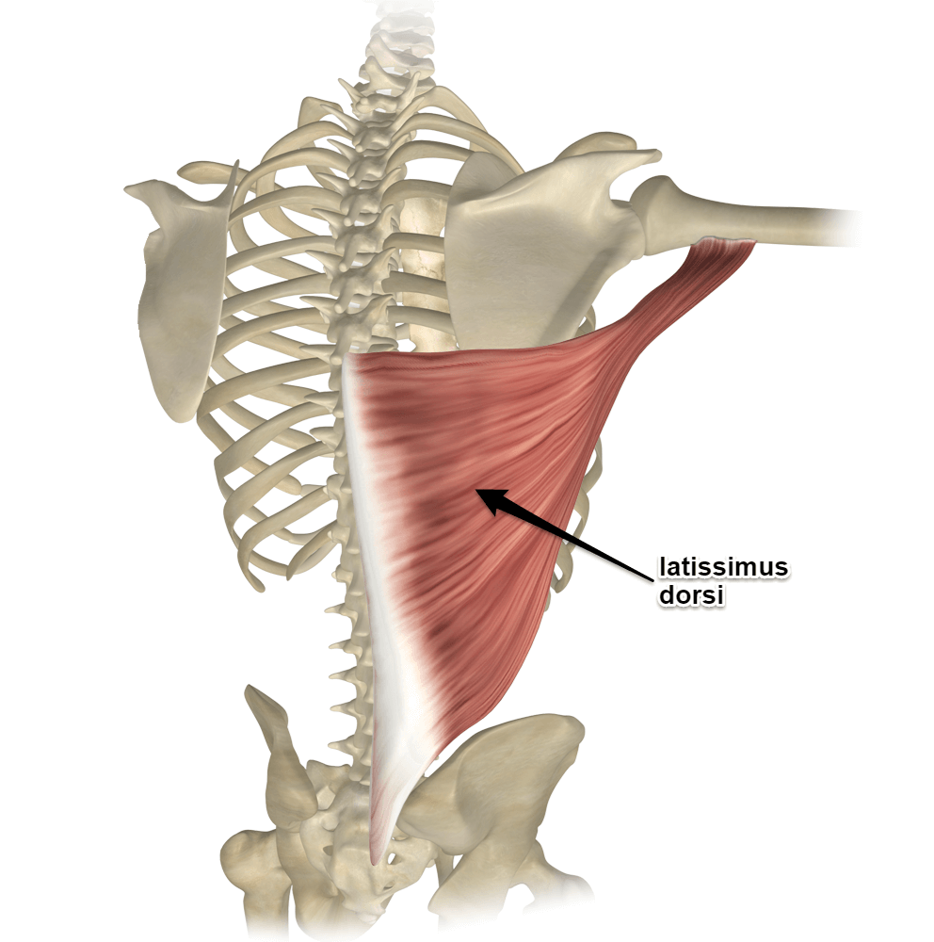
Stretching:
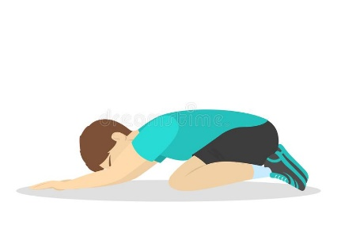
Stretching the lats can be done easily in a position called “child’s pose”. This position is done with your knees on the ground and bum to your heels. Keeping your bum on your heels, reach your arms out onto the ground as far as you can. You should feel the stretch along the both sides of your back. If you’re not feeling any stretch you can continue to reach to one side, then the other. Remember to hold your stretch for 10-15 seconds!

Strengthening:
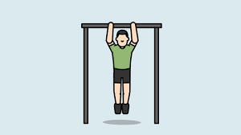
Strengthening the lats can be done in a variety of ways. An easy way for young people is swinging on the monkey bars, and trying to pull yourself up from the monkey bars using only your arms. This is also known as a chin up, or pull up.

