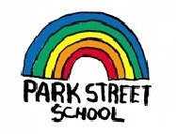
School Supply List
Grades 3 - 5 English

Park Street School
2019 – 2020

Have a wonderful summer – see you in September with the following school supplies ☺

1 set of headphones (can be inexpensive)
1 pair of indoor sneakers suitable for Phys Ed
2 boxes of Kleenex for whole-class use
1 large box of Ziplock baggies
$40.00 classroom fee (To be paid using School Cash online or a cheque made payable to Park Street School)
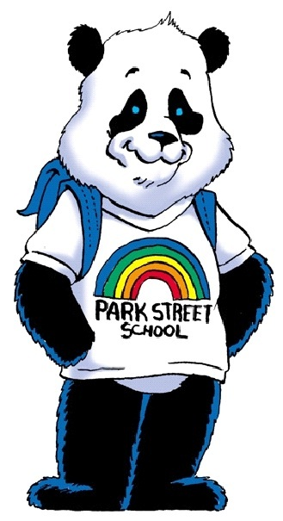
We look forward to working with your child in the upcoming year. See you on Tuesday, September 3!

