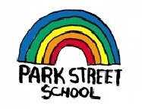
School Supply List
Grades 3 - 5 English

Park Street School
2022-2023

Have a wonderful summer – see you in September with the following school supplies ☺

1 pair of headphones (can be inexpensive)
1 pair of indoor sneakers suitable for Phys Ed
2 boxes of Kleenex for whole-class use
1 large box of Ziplock baggies (seal top bags 26.8 cm x 27.3 cm)
2 Black Sharpie Markers
2 Highlighters
2 (4 pack) Whiteboard markers for Learning Stations

((Most of these items can be found at the Dollar Store 😊))

$40.00 classroom fee (To be paid using School Cash online or a cheque made payable to Park Street School)

We look forward to working with your child in the upcoming year. See you on Tuesday, September 6!

