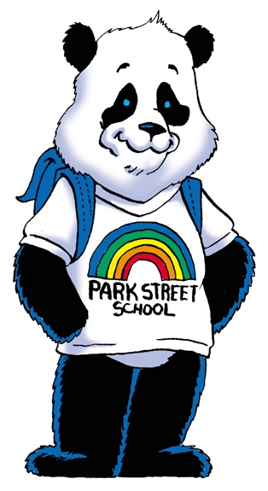

Dear Parents/Guardians,

Hello! My name is Mr. Paul MacArthur and I am the new music teacher for the 2019-2020 school year. You are receiving this letter and registration form because your child has shown an interest in joining the school orchestra program.

Important information to know:

- There is a registration form that is attached to this information letter. If your child will be joining orchestra, please fill out the form and have your child bring it back to me by September 20th at school along with the registration fee.
- The registration fee this year is $50, $25 in September and $25 in January. (Please make cheque payable to Park Street Elementary School)
- If financial assistance is needed please do not hesitate to contact Mr. Meesters, Mrs. Gauvin or myself (as we want all students to have the opportunity to participate).

Instruments

- If you need an instrument for your child, information regarding renting an instrument from Long and McQuade music store is also enclosed with this letter and form.
- Instruments that students may choose from this year are as follows:
  - Grades 1-3 violin
  - Grades 4-5: violin, cello (only if they have previous violin experience), flute, clarinet, alto saxophone, trumpet, trombone and percussion.
  - Students in grades 4-5 must have a 1st and 2nd choice instruments as there are only so many students able to play each instrument.
- If your child is playing something other than the violin or cello, please wait to hear back from me before renting an instrument.

Rehearsals

- Rehearsals will start Tuesday, September 24th, if your child joins orchestra, you will receive a rehearsal schedule letting you know exactly when their rehearsals will be held. Full orchestra (students playing cello, flute, clarinet, saxophone, trombone, trumpet, percussion and senior violin) rehearsals will be on the schedule, but they will probably not be starting until November.
- Students will not automatically be in the full orchestra until they reach a certain level “belt.” (Violin will be doing Orchestra Karate like last year, it is an incentive program encouraging students to practice). Once students reach the level of black belt, they will be invited to join the full orchestra, those students who were already in the full orchestra last year will automatically be in it again this year.

Concerts
- Students are asked to wear dark bottoms and will be provided with an orchestra t-shirt to wear during performances
- We will have a concert in December (date TBD) one in May, and will perform at the music festival in April.
- We require parent help to set up and clean up for all concerts.

Fundraising

- We will be doing fundraising for the orchestra program as it is very expensive to run.
- At this time we have two major fundraisers planned and we will need your help in running successful fundraisers. The first one will be our annual auction and the second will be a sponsorship style fundraiser.
- The Arts Auction will be in November and for this we ask you to go out into the community to gather items/donations to use as part of the auction.
- The Sponsorship program will be a yearlong fundraiser where we ask local businesses to sponsor our program. If you know anyone or any businesses that would like to donate it would be greatly appreciated if you could contact them.
- We will provide you will all of the information and paperwork at the start of each fundraiser.

If you have any other questions, please do not hesitate to contact me here at the school, or by email.

**Due to increased participation in Orchestra, Junior Choir and Glee over the years we are finding that we are in need of a parent committee to help with the overall organization of the music program. Being a part of this committee would include such responsibilities as: fundraising, supervision during concerts, chaperoning trips, clean up after concerts, etc. If you are willing to help out with this committee, it would be greatly appreciated and to join send me an email at paul.macarthur@nbed.nb.ca.

Thank you so much for your support!
Mr. Paul MacArthur
Music Teacher, Park Street School
paul.macarthur@nbed.nb.ca

