Park Street School
Summer Camp

Math, Science and Technology Camp | Creative and Language Arts Camp
This summer your child will:  - Learn  - Create  - Experiment  In curriculum-based and hands-on activities that are specifically built for our future scientists. | This program is great to enhance your child’s creativity in a week devoted to:  - Reading  - Writing  - Presentation skills  In curriculum-based activities that are addressed in the most creative and exciting way.
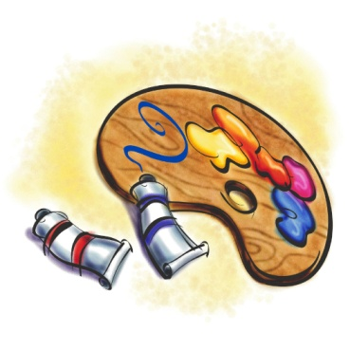
Park Street School
111 Park Street
Fredericton, NB E3A 2J6
Inquire at the office
or
Phone: 453-5423

