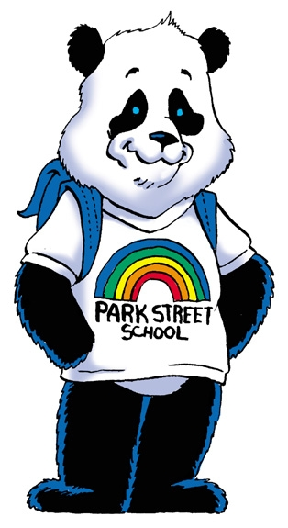
111 Park Street, Fredericton, NB E3A 2J6
Phone: (506)453-5423 Fax: (506)453-4255
Rien Meesters, Principal H.B.O.R/B.A., B.Ed., M.Ed., rien.meesters@nbed.nb.ca
Tarah Gauvin, Vice-Principal B.A., B.Ed., M.Ed., tarah.gauvin@nbed.nb.ca

Hello Park Street Families,

With week one underway I want to thank you for all that you have done for your students in preparing them for this school year. Please see below and the attached document that may support your questions or concerns.

- A family/student checklist for parents and guardians to use each day prior to sending their child(ren) off to school. It is attached.

- A very informative poster on how to safely wear a mask (from the Public Health Agency of Canada) is found at this link:

https://www.canada.ca/content/dam/hc-sc/documents/services/publications/diseases-and-conditions/covid-19-safely-use-non-medical-mask-face-covering/covid-19-safely-use-non-medical-mask-face-covering-en.pdf.

- The Department of Education and Early Childhood Development COVID-19 information site, which includes the “Return to School” documents is also a very important link to keep handy as it provides many updates:

https://www2.gnb.ca/content/gnb/en/corporate/promo/education-and-early-childhood-development-covid-19.html

- The attached Family Q&A could be useful for your families. Please review it and revise, as necessary, for your school if you choose to send it out (I think in particular of the Face Mask section…this may need revision). There is a lot of good, general information as pulled from the Return to School documents.

- Here is a neat video on transportation that could be helpful to parents: https://youtu.be/piWQuSVNIZw

Thank you,
Mr. R. Meesters

