 HOME LEARNING – Jan. 24th – 28th
Teacher page: http://priestmanstreet.nbed.nb.ca
SPECIAL MESSAGES:
Listed below is a guide for home learning for the next week. Everything your child
needs is in the learning package sent home today and we may use a few tools from last
week’s package so please hang on to both. I will continue to post daily videos showing
various literacy and math activities to be done using these materials. Please email with
any question/concerns.
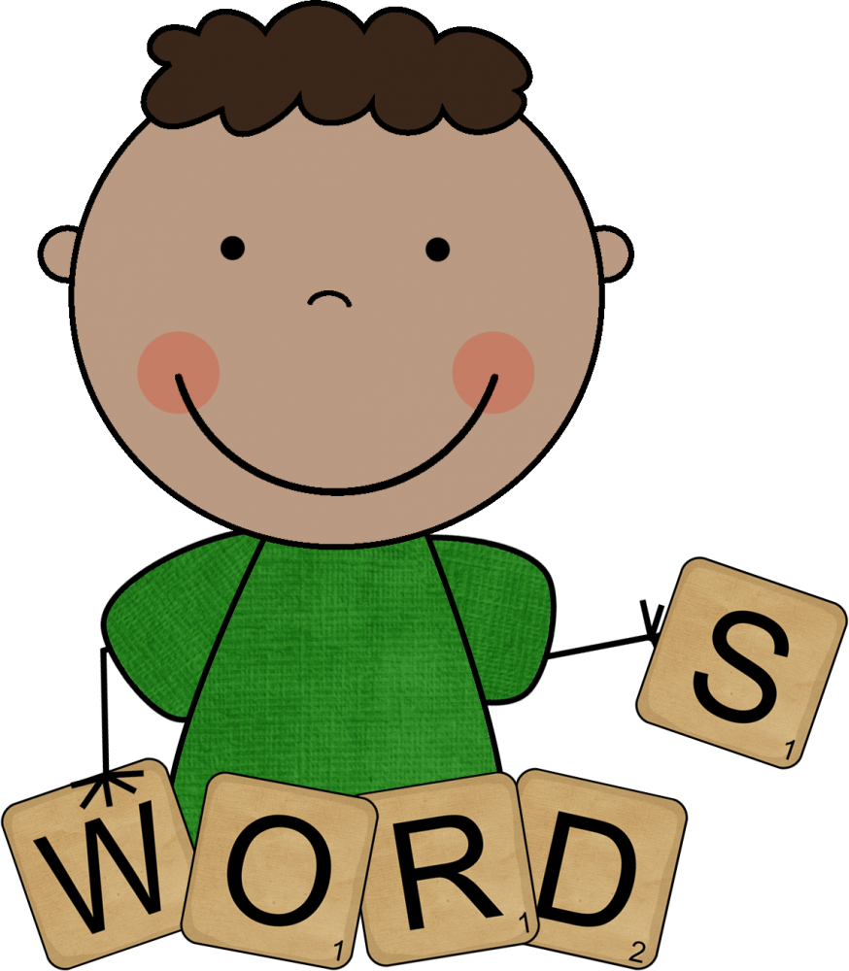
Spelling
The words we are practicing for the next 2 weeks are:
no so go going do
me we see she before
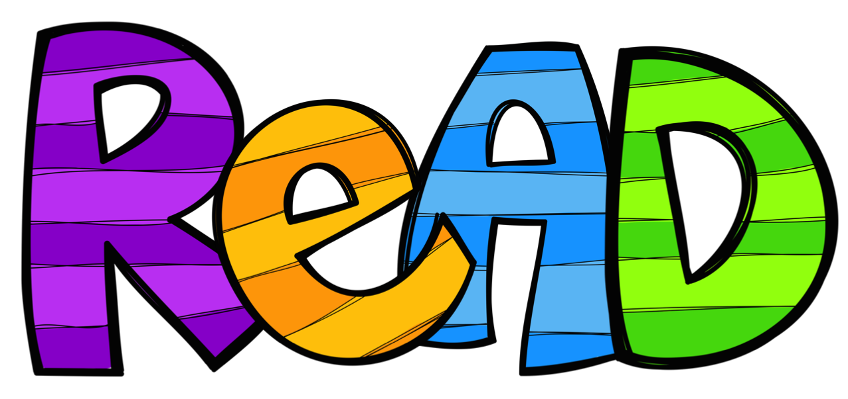
Sight Words
These are the words we are focusing on learning to read for February:
ride really rain quit pretty played phone people outside our other them then there they they’re thing

RAH RAH
I have purchased a new Raz kids account and placed your child’s new login card in their baggie. Please have them listen, read and do the quiz for at least one book each day. I have assigned them a level which should be a ‘good fit’ book but if you feel it is too hard or too easy please let me know and I will change it.

Math
I will post videos of math activites for your child to do.
In the meantime, please cut out the green flashcards to be used later today. Store them in an envelope or baggie for future use.
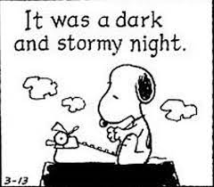
Writing
I will post videos with writing guidance for your child to complete.
Please keep all work in the learning package for the return to school.


