Review Sheet for Test on April 4th, 2019
Ratios, Percents, and Equivalent Fractions
- Students should be able to convert a percent to a fraction to a decimal. Examples:
  - 1/100 = 1 % = 0.01
  - 25/100 = 25% = 0.25
  - 10/100 = 10% = 0.10
- Students should be able to come up with a part-to-part ratio and a part-to-whole ratio. Examples:
- Part – to – part:
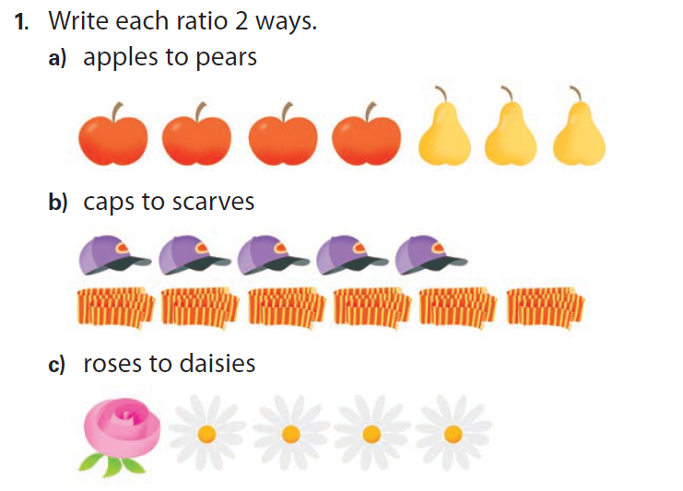 | - a) 4 to 3, 4:3, 4/3  - 5 to 6, 5:6, 5/6  - 1 to 4, 1:4, 1/4

b) Part-to-whole:
Write a ratio for cats to all animals. The answer is 3 to 7.
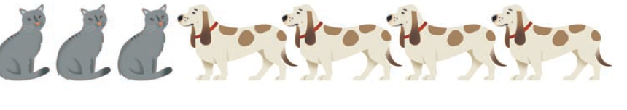
- Students should be able to find an equivalent fraction for a given one.
