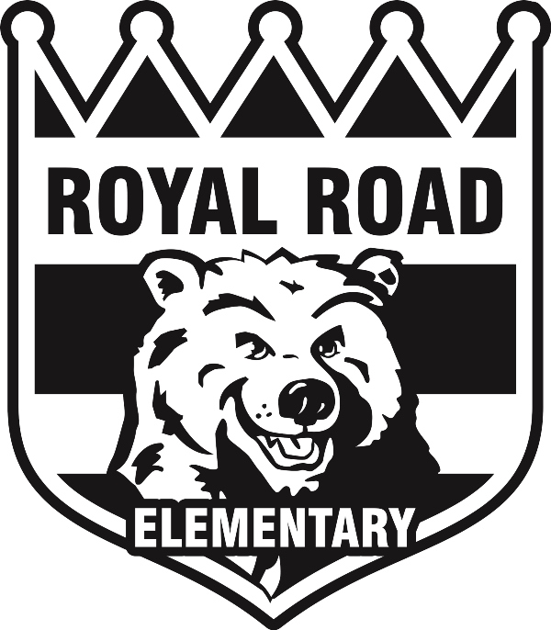Cross Country Running-Fall 2018

Dear Parents/Guardians,
Your grade 3, 4 or 5 child has the opportunity to participate in cross country this fall. Practices will be held on Mondays and Tuesdays during lunch hour, where students are expected to attend to be better prepared for the meets. Meets will be held every Wednesday afternoon.
Here are the following meets for the fall:

2018- Cross Country Dates
Date | Northside Location
Wednesday, September 19th | Gibson Neil
Wednesday, September 26th | Henry Park
Wednesday, October 3rd | McAdam Avenue
Wednesday, October 10th  (Rain date-October 17th) | District Finals  Nasis Middle School

*Please look at our Royal Road website online for cross country updates*

Transportation is not provided and is therefore up to the parents/guardians to make arrangements. Cross country will begin at 1:15 SHARP and end at approx 2:15. Please make sure your child has appropriate footwear and clothing (ex: sneakers only and shorts/jogging pants). We will be providing Royal Road shirts but we ask that they are returned at the end of each meet.
We will meet the students at each cross country site at 1:00.

If you have any questions please do not hesitate to ask. See you there!

Laura Douglas and Janet Crammond

Early Morning Rise and Shine 2018-2019

This year Royal Road is offering early morning rise and shine on Mondays and Fridays. We will begin on Monday, September 17th. Any child in grade 3, 4 or 5 is welcome to join us in the gym, as long as they are dropped off no later than 7:30. Students will have the opportunity to be engaged in low organized games, as well as work on skills related to our Phys Ed curriculum. We hope you can join us and look forward to seeing you bright and early!

Laura Douglas

