Welcome to the Dragon Family
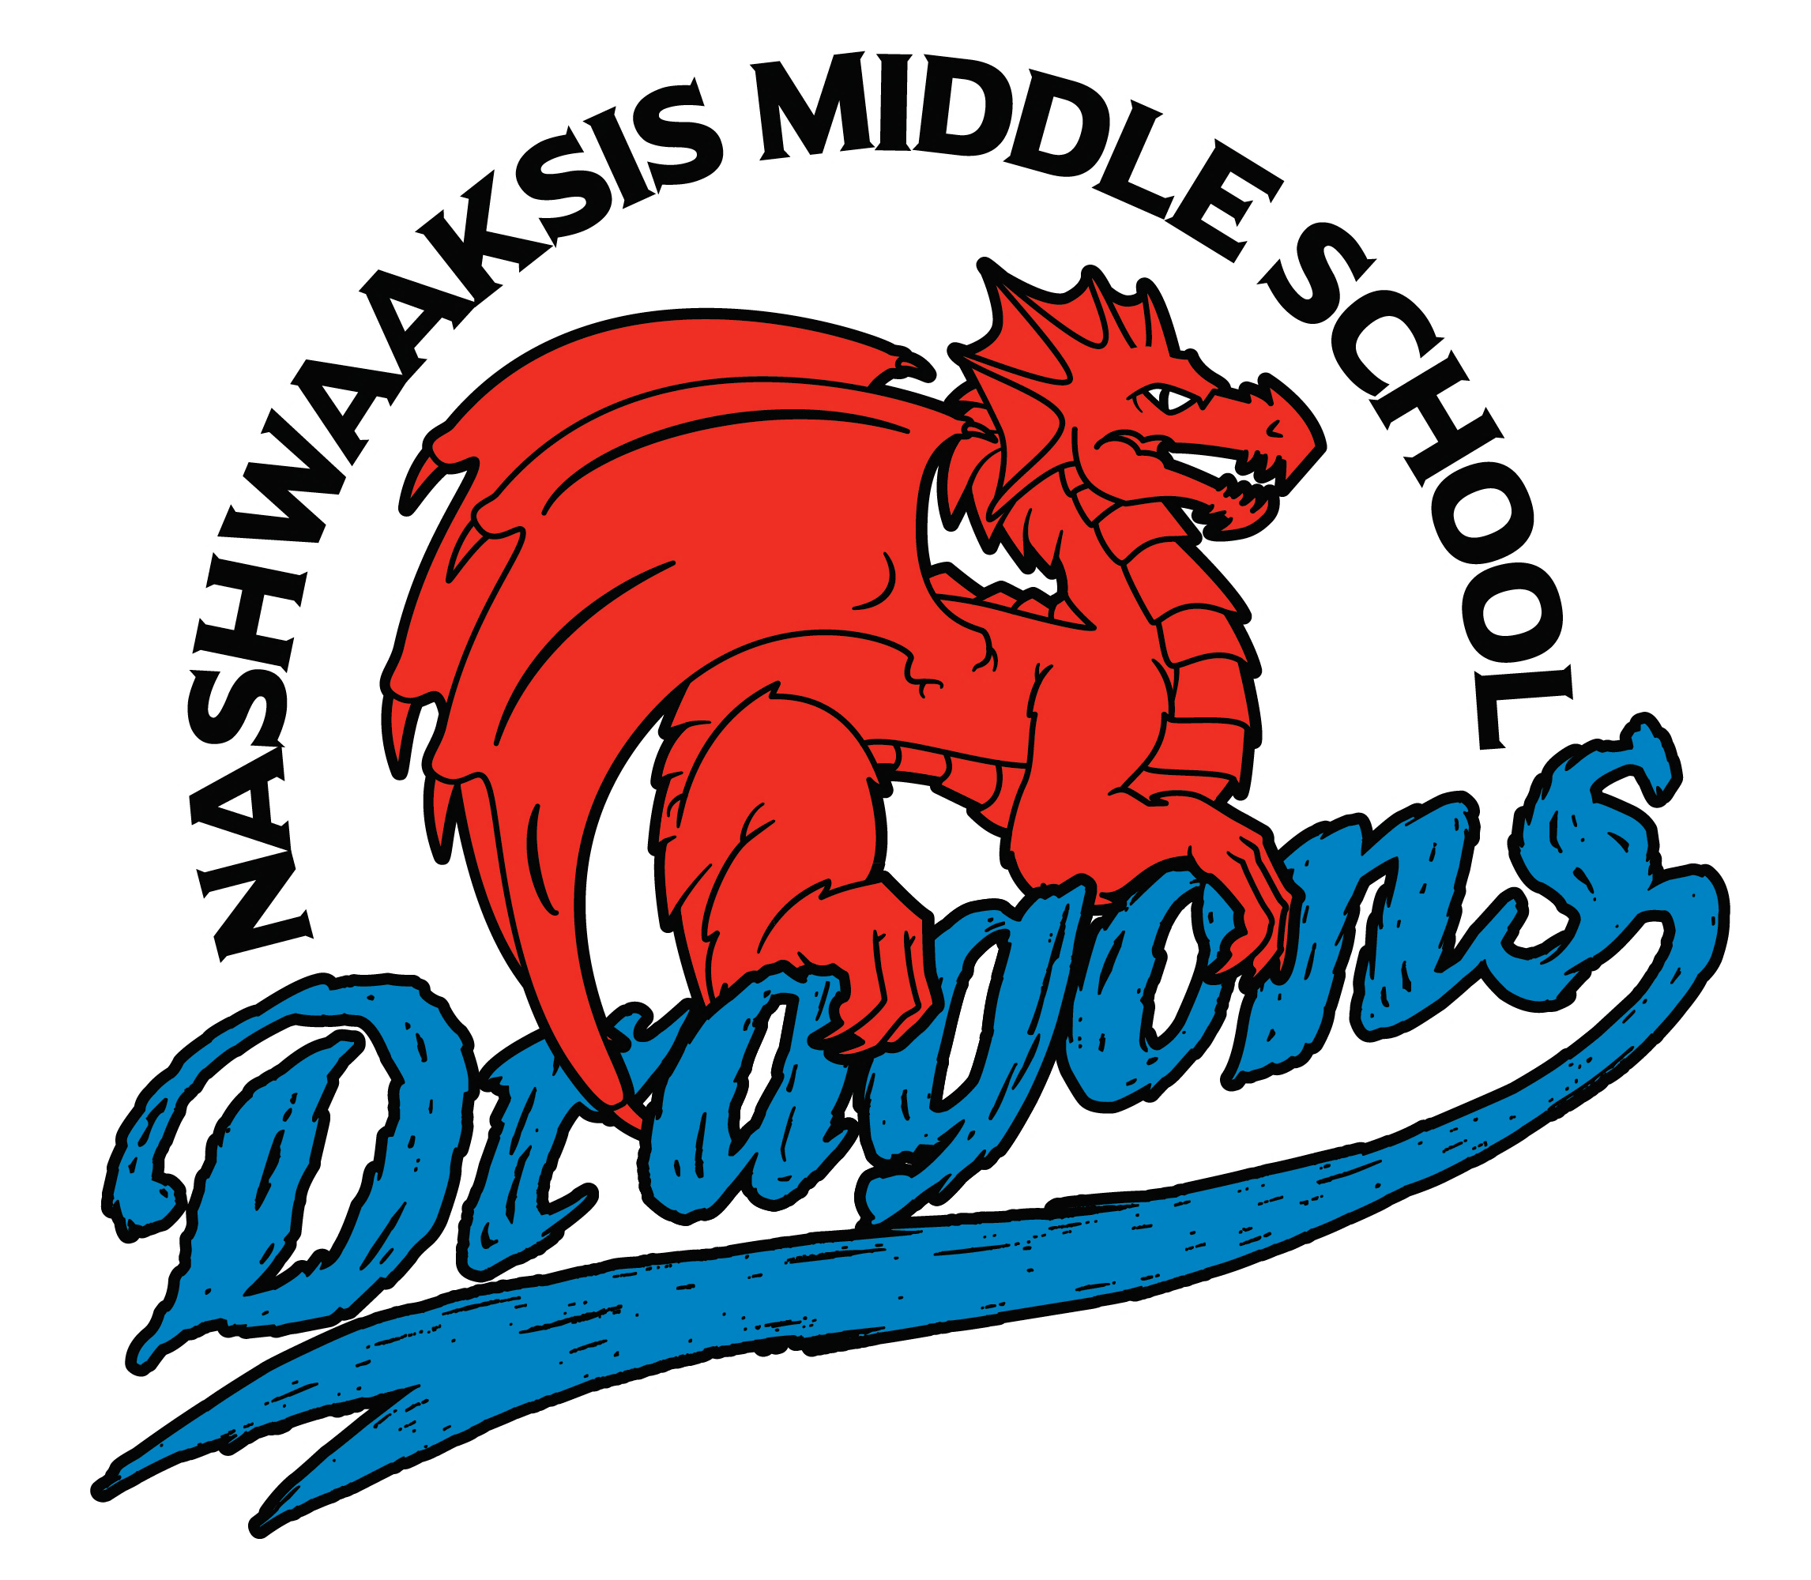

Care * Connect * Curriculum

We are excited to invite you to our
Grade 6 Orientation on
Tuesday, June 14th, 2022, at 6pm

