School Health Announcements K-5
Nutrition Month – Food and More
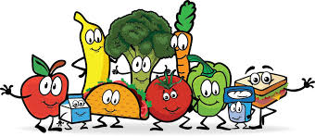

March is Nutrition Month…
- Feeling thirsty? Drink water! Water is the best way to quench your thirst and is important for your body. Try to avoid sugary drinks and remember to choose water as much as possible.

- Food is meant to be enjoyed with people. Eat your meals with your friends and family. Have conversations and share stories when eating with others. You will also spend more quality time with people who are important to you.

- Want to make vegetables more fun? Try creating a rainbow of colours. Mix shapes and textures together. Think about the food that grows in a garden, or the country where the food was grown. Let your imagination guide you.

- Take your time when eating and eat at the table. Try not to eat near the TV. You will enjoy your food more and be more focused on what you are eating.

- Healthy eating is about food… and so much more. Think about everything that is going on around you when you eat. Use your senses… sight, touch, smell, hearing and taste to explore your food. Being mindful is also a big part of healthy eating.

School Health Announcements provided by Kim Martin, Dietetic Intern

