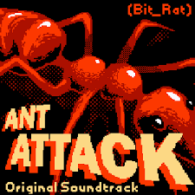
Ant Attack! A sight word game.
The parent chooses a sight word from their home word wall and draws blank lines representing each letter in the chosen word. This can be done on paper or wipe board. The child guesses letters. If they guess the wrong letter for the unknown word you draw the body of the ant. If they guess the right letter have your child fill in the letter in the blank. This continues until your child guesses or spells the word. If they guess the word they are safe, but if you finish drawing the ant before they guess the word the ant has attacked and the ant wins. Ant body parts include: The body, the head, the eyes, the antenna, the legs (6). This game can be played for several words. Have fun!

