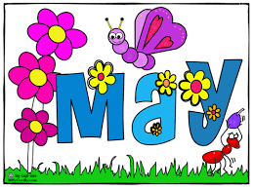
Week of May 15-19, 2017
May 15 – Professional Learning Day – No School for Students
Continuing to learn about reading strategies this week and continue with the same sight words.
Monday – Read and discuss meaning of home reading texts. Call out some words from the ‘Reading Sheet’ and have your child print the words.
Tuesday – Read books for second night. Play ‘Roll a Short Vowel’. You’ll need a die and a marker for each player. How to play: Take turns rolling a die. Match what you’ve got to the key at the top of the game board i.e. if you land on 2, move to the closest word with the short ‘a’ sound. Continue to play until someone lands on ‘fin’ winning the game.
Pack library book.
Wednesday – Read new home reading books. Call out words from the ‘Reading Sheet’ and have your child print the words. Choose different words from Monday.
Thursday – Read home reading books for a second night. Play ‘Roll a short vowel’.
Have Fun!
Important Note: There is lots of learning still to be done before the end of the school year. Please make sure your child is getting plenty of sleep at night. Also, with spring comes mud, please make sure your child has a change of pants and socks in case they get wet/muddy on the playground.
Thank you for your support!!
Mrs. Brooks

