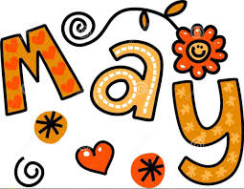
Week of May 22-26, 2017
Monday – No school – Victoria Day
Tuesday – Read two books for home reading. Play new short vowel game for ‘e’ and ‘a’.
Wednesday – Read two books for home reading a second night. Read through all sight words. Call out a word at random and have your child print it on paper or a wipe board.
Thursday – Read two books for home reading. Play short vowel game for ‘e’ and ‘a’.
Friday & Weekend – Read two books for home reading a second night. Review all letter names and sounds. Read through all sight words. Call a word out at random and have your child print it on a piece of paper or on a wipe board. Have your child read through words from the reading sheet (blend the sounds to read the word). Next, call out some of these words at random and have your child print them (stretch the sounds to spell the words).

