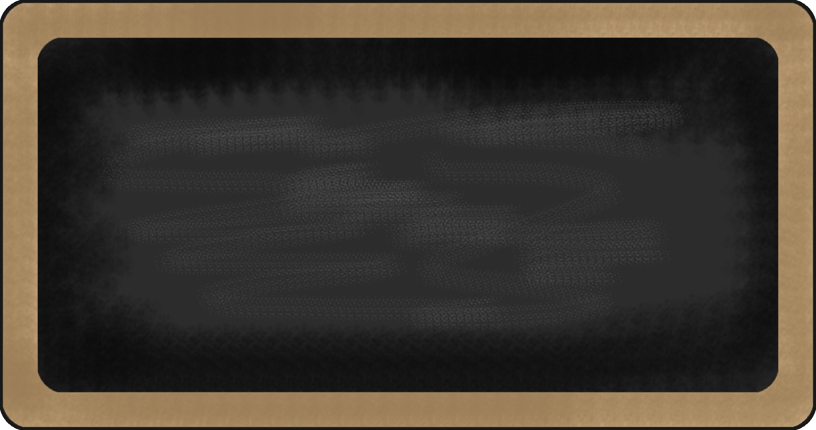

Kindergarten News

Sight Words
me

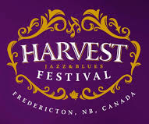
Upcoming events

September 14th – Jazz and Blues Performance

Reading | Writing | Math | You and Your World
- Jolly Phonics - Letters: s, a). | - Drawing pictures to convey a message or idea. | - Creating and identifying patterns  - Numbers to 5 | - School safety (fire drills, lockdowns)  - School rules and classroom routines

Notes from the teacher:
Please read over and fill out the forms that were sent home last week. Thank you to those who have already completed them! It is important that all information is up to date and everyone is informed on school events and procedures.
Thank you for sending in your child’s school supplies and $25 supply fee. If you have not yet sent them in, please do so as soon as possible.
If you have any questions or concerns please feel free to contact me at laurel.dyker@nbed.nb.ca, or call the school.



What we are learning this week:

