Name: __________________________________________________________________
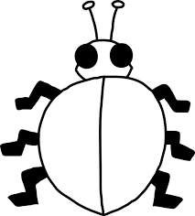
Show 9 in 5 different ways on the backs of the ladybugs, by making dots that equal to 9. Print the number below each wing and notice how although the parts are different they always equal 9.

