Sight Words

Review:
the, of, and, to , a
Kindergarten News

Upcoming events

January 22 – Skating Field Trip at York Arena (10:00 – 11:00 am)
January 25 – Parent Morning (8:30 – 9:30)

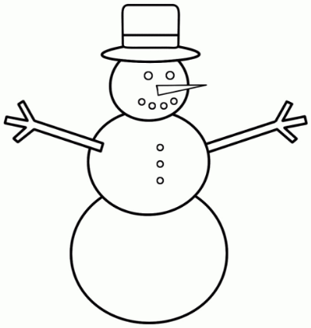

Notes from the teacher:
Homework reading will begin next week. The Read at Home Program (RAH RAH) should be done every day. Students will have a RAH Duotang which will help them keep track of the books they read. Students are responsible for recording the book titles in their reading logs. Parents can help with the dates. Please enjoy reading with your child!
Please ensure your child is dressed for the weather (snowpants should be worn every day). Waterproof gloves/mittens are highly recommended to keep your child’s hands dry and warm.
Please continue to encourage your child to independently dress themselves.
Our school breakfast program started this week! More details to follow.
Thank you to ALL that came to our skating outings! We had fun!


What we are learning this week:

Reading | Writing | Math | You and Your World
- Jolly Phonics Review – s, a, t, i, p, n, c, k, e, h, r, m, d, g, o, u, l, f,  - New Letters: f, b, j, z, w, v, y  - Short Vowel Review - /a, e, i, o, u/  - Sound: /ai/ Rule: “When two vowels go walking, the first one does the talking.” | - Printing Practice (upper & lowercase)  - Conventions – Capitals to start a sentence, punctuation to end them, spacing  - Writer’s Workshop: Writing what is in your head (with pictures and words).  - Writing about our experiences. | - Using mathematical language to compare number sets (most, least)  - Representing numbers in different ways  - Continue with numbers to 10  - Counting forwards and backwards between 0 and 10.  - Subitizing (up to 5) – “to know how many there are without counting” | - Healthy interactions with peers, teachers and family.  - Healthy lifestyles – personal hygiene and physical activities

Please contact me if you have any questions or concerns:
rolly.sidik@nbed.nb.ca

