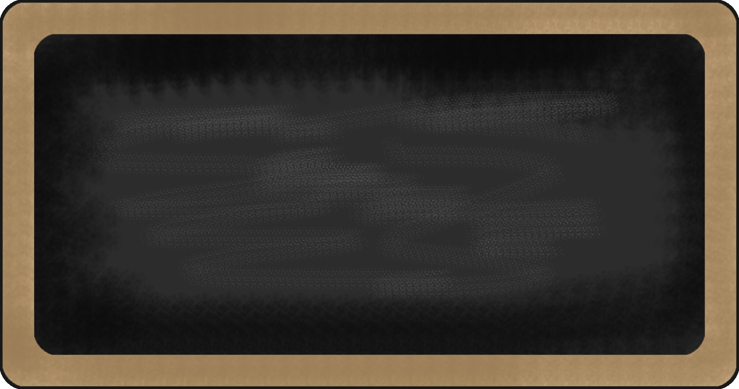

Kindergarten News

Sight Words
me, I, to, is

Upcoming events
October 12th – Picture Day!
Safe School Week
October 15th – Bus Safety
October 16th – Lockdown Practice
October 17th – Fire drill Practice
October 19th – School Evacuation
October 26th – Halloween Howl

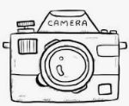
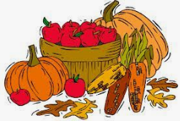



Notes from the teacher:
Our first field trip of the year was a success! Everyone looked like they had fun on our apple picking excursion. Thank-you to those who were able to volunteer.
Students are working on whole-body listening and building their stamina to focus on the task at hand. Keep up the hard work!
Please refer to the letter formation guide being sent home when working on letter formation---thanks!
Thank you to everyone who sent in their school fees and supplies!
If you have any questions or concerns please feel free to contact me at crystal.bragdon@nbed.nb.ca, or call the school.



What we are learning this week:

Reading | Writing | Math | You and Your World
- Jolly Phonics- Review letters: s, a, t, i, p, n, c/k and e  - Review sight words: is, to, I, me | - Practice writing proper letter formations for: p, n, t, i, s, a, c/k, e  - Practice writing and spelling sight words: is, me, I, to  - Practice writing their names | - Identify and reproduce patterns  - Sorting  - Numbers to 5  - Recognize at a glance and name familiar arrangements of 1 to 3 objects | - W.I.T.S. Strategy (Walk Away, Ignore, Talk it out, Seek help)  - School safety  - Habit 1: Be proactive.  