

Kindergarten News

Sight Words Review

in

Upcoming events
December 11th – Christmas Concert (1st Show – 9:00 am/2nd Show – 11:00 am)
December 12th – Wear a festive sweater for $1 (Fundraiser for the Fredericton Community Kitchen)
December 13th – Christmas Dinner for students
December 14th – Home & School Christmas Baskets draw for winner
December 18th- Wear your School Team T-shirt (If you don’t have one, a top of the same colour works too!)
December 19th - Wear PJ’s for a 1$ (Fundraiser for the Fredericton Community Kitchen)
December 21st – Last day of school before the winter holidays



Notes from the teacher:
Holidays are around the corner, but we still have a lot of work to do! We can do it! Stay focused!
Please continue working with your child to dress into and out of their winter clothes independently.
Library is on Thursdays. Please return your books in order for your child to borrow a new one.
Please continue to practice letter recognition & sounds, sight words and counting regularly.
If you have any questions or concerns please feel free to contact me at rolly.sidik@nbed.nb.ca, or call the school, (506) 453-5438.

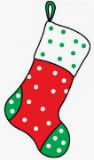

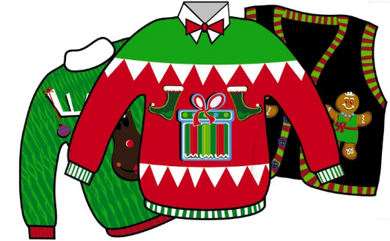
What we are learning this week:

Reading | Writing | Math | You and Your World
- Letters: x, z  - Sight Word: he  - Strategy: Lips the Fish – Get your mouth ready. Say the first sound.  - Review letters: s, a, t, i, p, n, c/k, e, h, r, m, d, g, o, u, l, f, b, j, w, v, y  - Practice reading sight words | - Writing words that match their drawings  - Practice proper letter formations for: x, z, v, y, j, w, f, b, u, l, o, p, n, t, i, s, a, c/k, e, h, r, m, d, g, o  - Practice writing and spelling sight words  - Practice writing their names | - Say the number sequence 0-10 forwards and backwards  - Represent and describe numbers  - Subitizing 1-5 objects  - Relate a numeral to its quantity 6 to 10  - Identify, create and reproduce patterns with 3 elements in the core | - Recognize and respect the various traditions, rituals and celebrations of families  - W.I.T.S. Strategy

