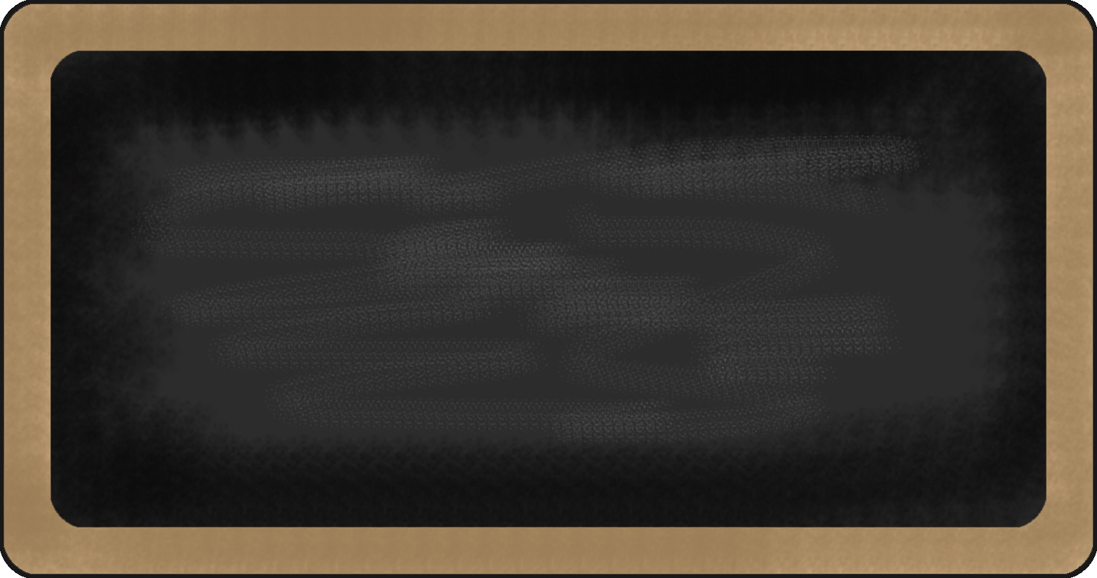

Kindergarten News

Sight Words
I


Upcoming events

October 12th – School Photos
October 15 – 19^{th -} Safe School Week

Notes from the teacher:
There are confirmed cases of head lice in the school. Be sure to check your child’s hair for nits and lice for the next couple of weeks.
Please return updated information and permission forms if you have not already done so; thank you.
School supplies and the $25 supply fee are due. Thank you for your support!
Thank you for sending shoes and clothing that your child is able to put on by themselves. Building independence is an important part of learning!
If you have any questions or concerns please feel free to contact me at rolly.sidik@nbed.nb.ca, or call the school.


What we are learning this week:

Reading | Writing | Math | You and Your World
- Jolly Phonics – New Letters /t/, /i/  - New sight word: I  - Review letters: s, a  - Review sight word: me | - Practice writing proper letter formations for t, i, s, a  - Practice writing and spelling sight words: me, I | - Creating and identifying patterns  - Numbers to 5  - Sorting objects by a single attribute (eg. Sorting by colour, size, shape etc.) | - School safety (fire drills, lockdowns)  - Rules in the classroom and in the school.  

