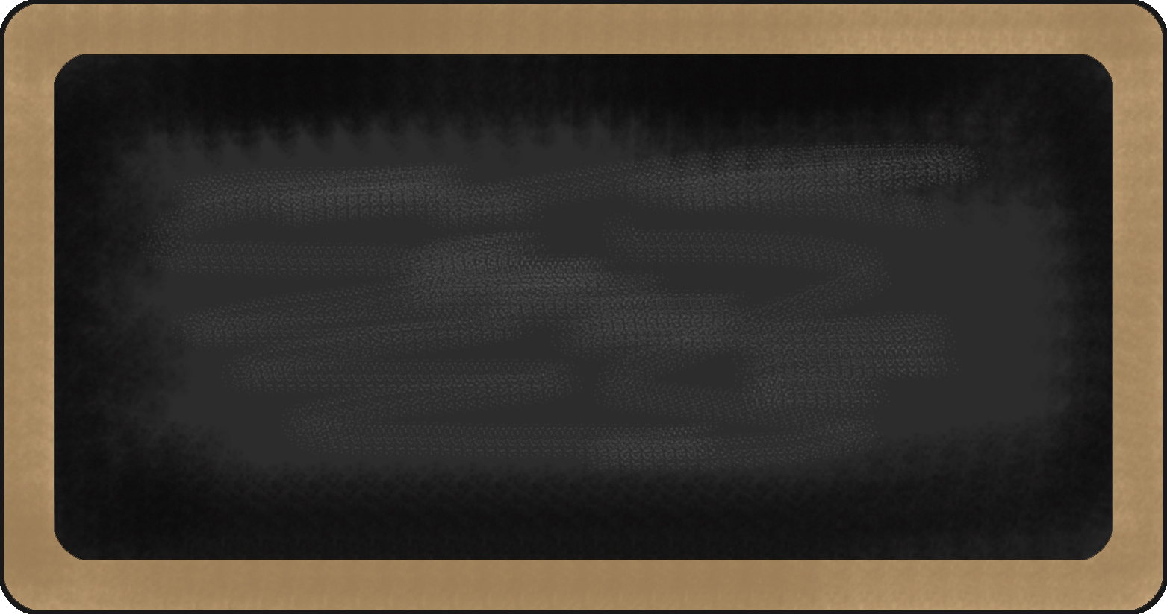

Kindergarten News

Sight Words
to

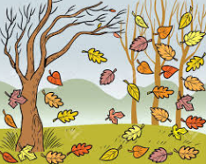
Upcoming events
September 25th – Terry Fox Walk- you are welcome to donate a loonie to the cause.
October 2nd – Apple Picking at River Views Orchards
October 4th – Thanksgiving Dinner for students
October 12th – Picture Day!
October 15 – 19^{th -} Safe School Week



Notes from the teacher:
Wear something with a pocket on Tuesday to celebrate the letter Pp. Place a small object in your pocket and come with a clue so we can guess what is in your pocket.
Gentle reminder to pay the $25 school fee and send in supplies if you have not already done so. Thank you to everyone who did! ☺
The weather is starting to get cooler. Please make sure your child is dressed accordingly.
Many students are adjusting smoothly to their new school routines. Way to go! We are continuing to build stamina for whole-body listening and staying on task.
If you have any questions or concerns please feel free to contact me at crystal.bragdon@nbed.nb.ca, or call the school.

What we are learning this week:

Reading | Writing | Math | You and Your World
- Jolly Phonics – New Letters /p/, /n/  - New sight word: to  - Review letters: s, a, t, i  - Review sight word: me, I  - Poem – Two Red Apples | - Practice writing proper letter formations for p, n, t, i, s, a  - Practice writing and spelling sight words: me, I  - Practice writing their names | - Creating and identifying patterns  - Identifying the core of a pattern (the part that repeats)  - Numbers to 5 | - School safety (bus safety, fire drills, lockdowns)  - Rules in the classroom and in the school.

