Grade 4 To Learn To Grow To Lead
 | ~October 2016 ~
Literacy | Mon | Tue | Wed | Thu | Fri | MATH
Select, with growing independence texts. Describe, share and discuss their personal reactions to texts.  Conventions, spelling, punctuation, capitalization and paragraphing. Formulate goals for learning.  Introducing “Book Talk”  Students will be asked to bring in their favorite book and share with a small group. Please begin thinking about a Book you would like to share!  (Ideas: chapter book, picture book, magazine or any other piece of favorite reading material) | 3 | 4  Thanksgiving Dinner  $5.75 | 5  Cross Country  School Spirit Day!  Scholastic Book Orders Due! | 6  No School  PD for Teachers | 7  No School  PD for Teachers | - Students will represent and describe whole numbers to 10 000 pictorially and symbolically. (N1)  - Students will compare and order numbers to 10 000. (N2)  - Students will identify and explain mathematics relationships using charts and diagrams to solve problems. (PR4)  - Students will demonstrate an understanding of addition of numbers with answers to 10 000 and their corresponding subtractions by using personal strategies for adding and subtracting, estimating sums and differences, and solving problems involving addition and subtraction. (N3)
 | 10  No School  Happy Thanksgiving | 11  School Evacuation | 12  School Lockdown  Walk to School from St. Theresa’s Church (7:15am) | 13  Fire Drill | 14  Bus Evacuation
 | 17 | 18  PSSC meeting | 19 | 20 | 21
 | 24 | 25  School Book Fair | 26 | 27 | 28  Halloween Howl  Picture Retakes
 | 31  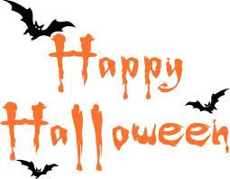 | Happy Birthday to: Jonathan and Tyson |  |  | REMINDERS:  - $25. Student fee

