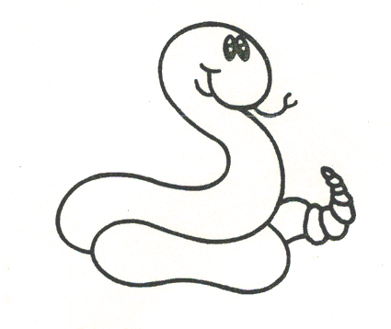

******************************************************************

“S-t-r-e-t-c-h” it out!
- Stretch the word out slowly.
- Put the sounds together to figure out
the word.
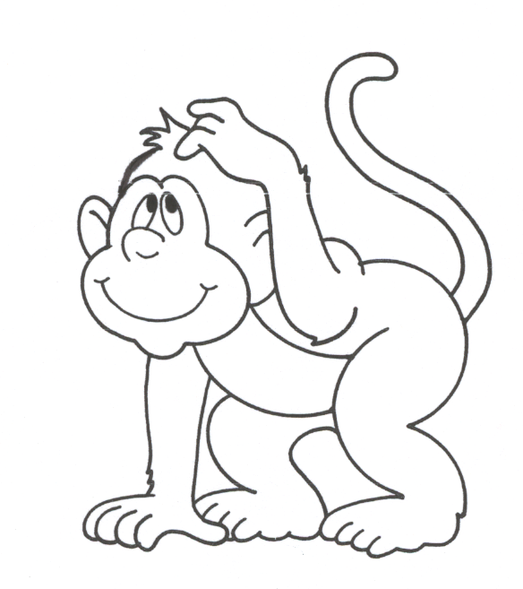
******************************************************************

Chunk the Word!
- Look for a “chunk” that you know
(-ing, -and, -art, -old, etc.).
- Look for a word part (be-, -er, etc.)
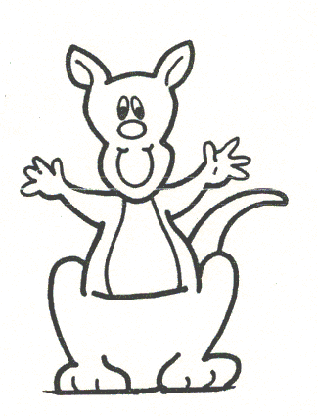
******************************************************************

Ask For Help!
- After you have tried all of the other
strategies, ask for help.

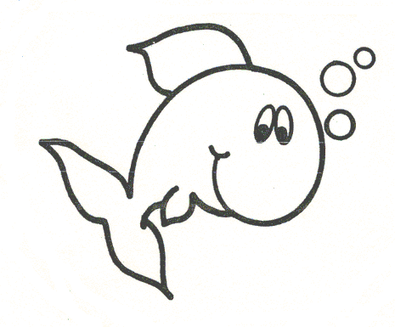
******************************************************************

Get Your Lips Ready!
- Say the first few sounds of the word
out loud.
- Read to the end of the sentence and
say the sounds again.
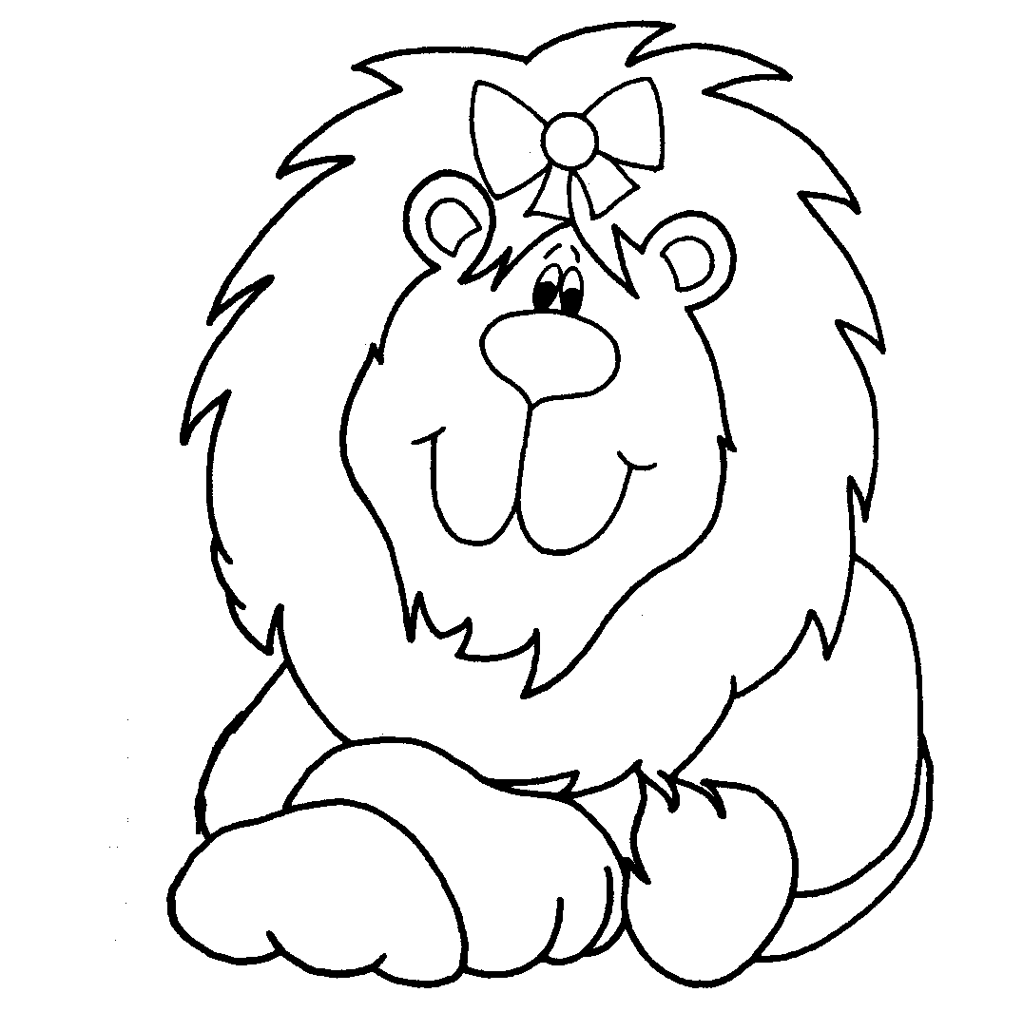

******************************************************************

Try It Again!
- Try to reread the sentence.
- Try a word that makes sense.

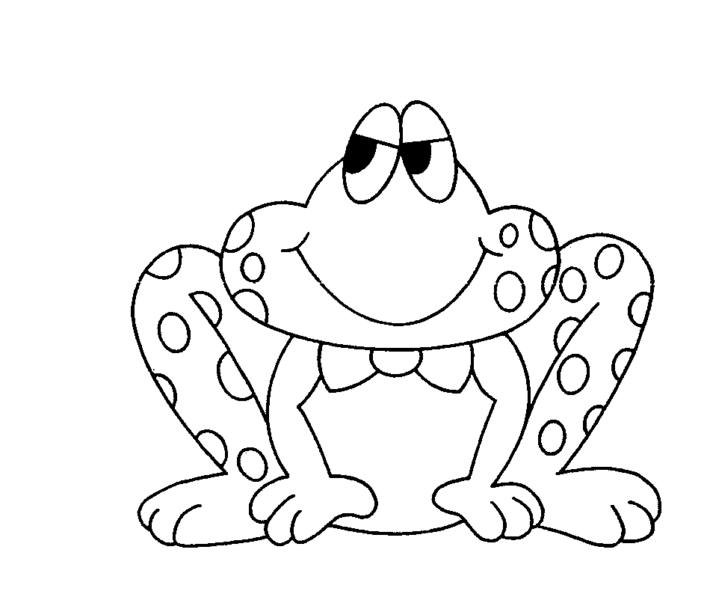

******************************************************************

Skip It, Skip It!
- Skip the word (“skip it, skip it”)
- Read to the end of the sentence.
- “Hop back” and read it, read it.

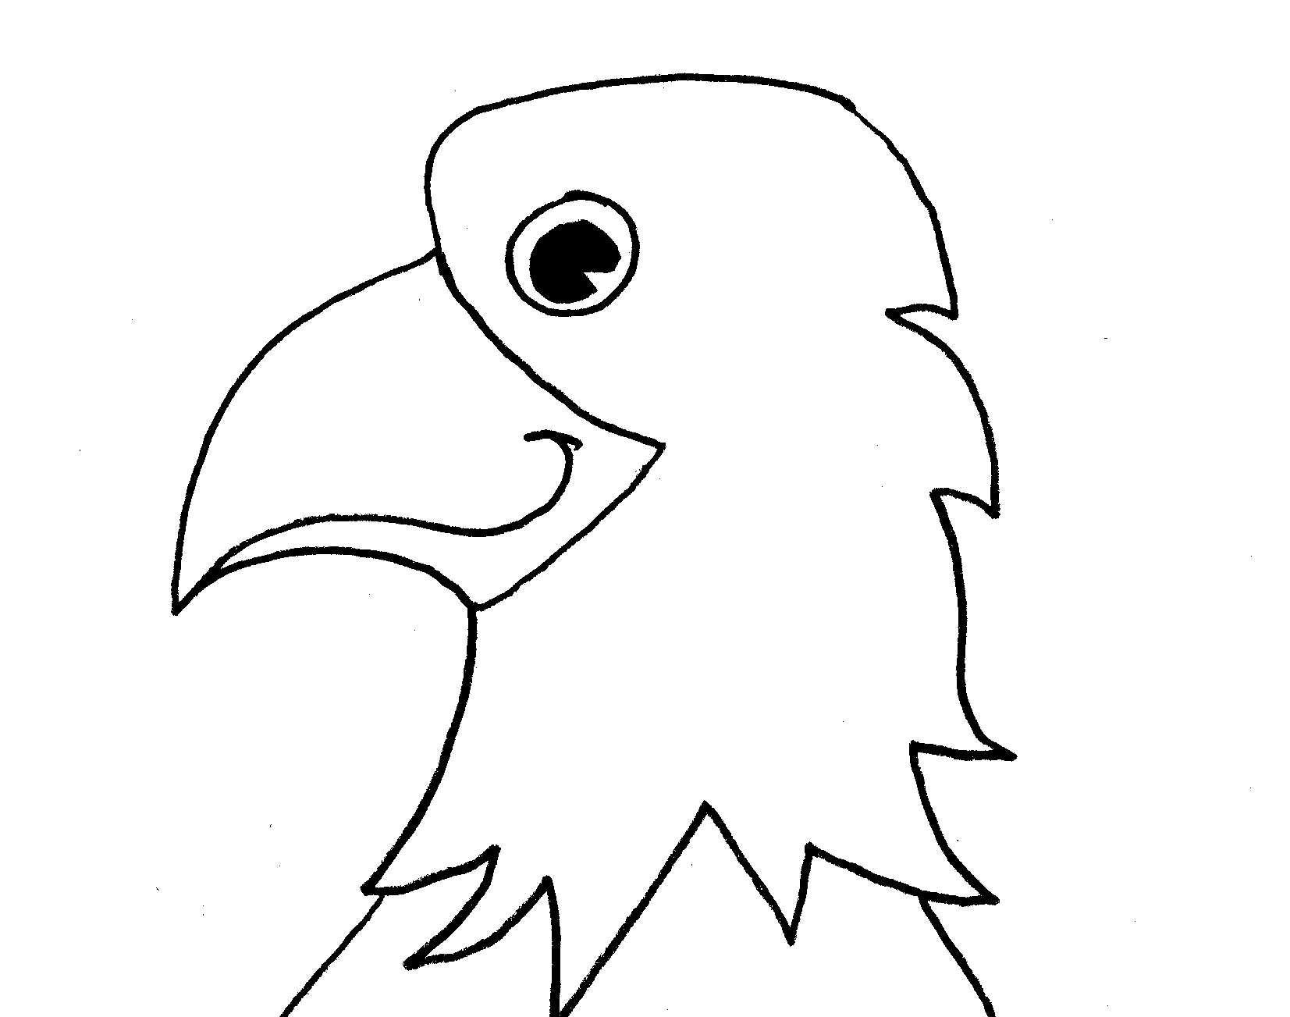

******************************************************************

Look at the Pictures!
- Look at the pictures for clues to help
figure out the word.

****************************************************************

Flip the Vowel Sounds!
- Try the other vowel sound.
- If the short vowel sound doesn’t make sense, then try the long vowel sound.
- Which one sounds right?

