Stanley Consolidated School Presents

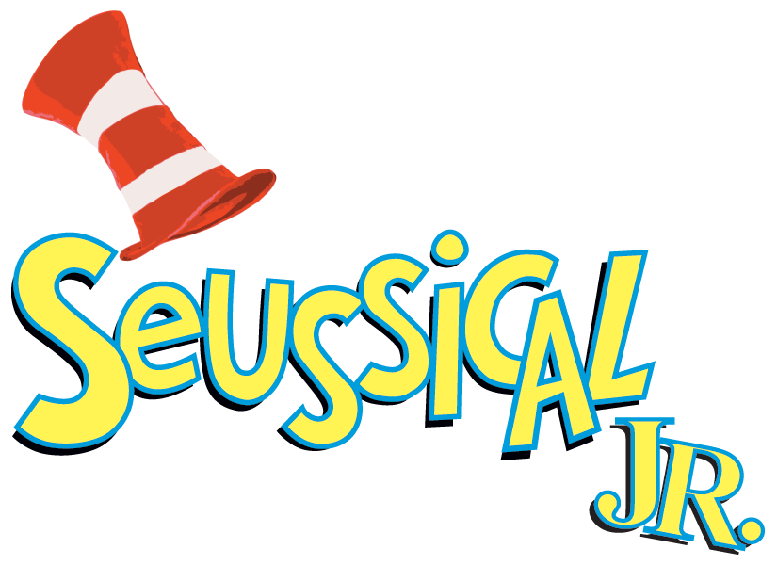

Wednesday, April 26th
Thursday, April 27th
7:00 p.m.
SCS Cafeteria
Adults $10.00
Children $5.00
Available at the door

Music by Stephen Flaherty
Lyrics by Lynn Ahrens
Book by Lynn Ahrens and Stephen Flaherty
Co-Conceived by Lynn Ahrens, Stephen Flaherty and Eric Idle
Based on the works of Dr. Seuss
Music Supervised, Adapted and Produced by Bryan Louiselle

