

**Townsview School Guidance Program:**

**May Newsletter**



[](https://www.youtube.com/watch?v=kPO21NiUbU0)[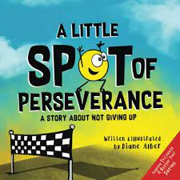](https://www.youtube.com/watch?v=EVwsyzJmTHM)[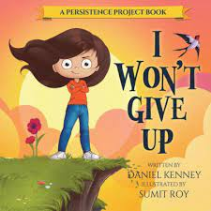](https://www.youtube.com/watch?v=jE-kT6vf4Kc)[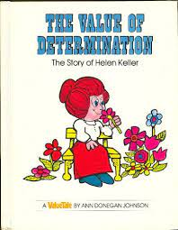](https://www.youtube.com/watch?v=EpLPt7ty1yg)

Click the pictures to link to story read alouds

**BY JESSICA WOLSTENHOLM**

**Tips for Encouraging Determination**

**If your child is struggling, brainstorm together about what steps they can take to overcome. Share your own experiences, mistakes you’ve made, and ways you have learned to persevere through difficulty.**

**Encourage a growth mindset. A**[**growth mindset**](https://www.gominno.com/blog/how-to-talk-to-your-kids-about-their-strengths-and-weaknesses)**says that their natural talents and skills can be developed through hard work, education, and perseverance. If you want to encourage a growth mindset, instead of praising kids for “being smart,” consider praising them for “working hard” or “getting better.”**

**Push them to try things they aren’t naturally good at. If we only try things that come easily to us, we will never experience what it means to overcome!**

**The goal of life isn’t perfection, it’s growth. Instead of focusing on the end result, determination focuses on the journey. Encourage your kids every step along the way—the little things and the big things; the goals met and the “good tries.”**

**Teach and show them that failure is okay. Talk with your kids regularly about your own failures, mistakes, and how you persevered through them or how you could have been more resilient. You can even share stories of famous successful people who have had major setbacks or failures and how they overcame them.**

**Theme of the Month**

The school-wide focus for May is **Problem Solving(K-5)** and **Managing Relationships and Social Conflict (6- 8).** Problem Solving is the process of finding solutions to problems encountered in life. This process includes defining a problem, determining the cause of the problem, identifying a solution, and implementing that solution. Managing Relationships and Social Conflict allows students to learn the ways that they can maintain a healthy relationship and use strategies and problem solving during social conflict in an appropriate way.

The **behavior of focus** for all students will be ‘’determination”. Here at school, we often call this quality ‘**GRIT’.** During the month of May, students will learn the importance of not giving up, and to keep trying no matter what!

**Guidance Program**

Throughout May, guidance will continue supporting and enhancing student learning through academic, social-emotional, and career development. The ESS (Guidance) teacher supports whole school initiatives (such as the Second Step and Link Program), by providing resources, activities, co- planning, co-teaching, and offering small group/individual learning opportunities related to general guidance curriculum outcomes (such as emotional regulation and friendship groups). If you have any questions about the guidance program at TVS, please feel free to contact me at the school: 506-325-4435 or [Jessica.Irvine@nbed.nb.ca](mailto:Jessica.Irvine@nbed.nb.ca).

Jessica Irvine