Hello again, Grade 8s! Week Three of Learning Continues!

Feel free to contact me @SarahSadlerMean@nbed.nb.ca

Or call the school @ 278-6000

This week’s suggested learning activities include the following, but feel free to click on any other teacher at http://web1.nbed.nb.ca/sites/ASD-W/bms/Pages/default.aspx for a variety of activities that may suit your child’s needs or interests. Just click “weekly learning plans” and you’re all set!

Note to Parents: Free lunches will be available from the Diner Down Under at 12:30 daily for those in need until further notice.

Also, don’t forget to enter your child in the draw for a free bike thanks to a partnership with Thomas Equipment and BCS! Submit a story or picture of how you are maintaining a positive mindset while remaining physically fit! Email your submissions to BathCommunity@nbed.nb.ca, or drop your submission in the mail.

Students are encouraged to get a minimum of thirty minutes of physical activity each day. To help you do that, check out Mr. Williams’ suggested activities at the BCS website (see the link above)

Literacy: Please remember to read for thirty minutes or longer every day, if possible! I’ve included all the parent emails that I have onto my EPIC! Account so that students can read from home, and I can see who is reading and for how long!

Literacy Activities: Writing Prompts (half-page or more for each. Choose any three)
- Finish this sentence in at least 10 different ways: The Earth needs our help because…
- Your local mayor wants to hear your ideas on how the city can save water or electricity. Write a letter to the mayor explaining your idea. You could even include a diagram in your letter.
- Write a haiku poem about saving Earth. Remember haikus have three lines with the following syllable pattern for each line 5, 7 and 5.
- Create a poster for Earth day and include a snappy slogan that will encourage more people to protect Earth.
- Write a step-by-step guide on how to use less water in your home.
- Write a natural disaster story, using the following as a story starter: If only I watered my plant like my mom told me to…
- Write three acrostic poems using the words, Earth, recycle and nature.
- Write a story about a man who hates recycling and then learns the importance of recycling.
- Write a shape poem on how to take care of Earth in the shape of the planet.
- You read a newspaper article with the headline, “Recycling – A Waste of Time!”. Write a letter to the editor of the article, convincing them that recycling is important.

Science: Earth Day is April 22! This is the day we remind students about the importance of recycling in order to save the planet for future generations! Knowing your plastics can come in handy!

Which Plastic is Which?
You know those recycling codes on the bottom of your plastic containers? They tell you what type of plastic they are. Here’s a quick explanation of the typical plastics used in consumer products these days:
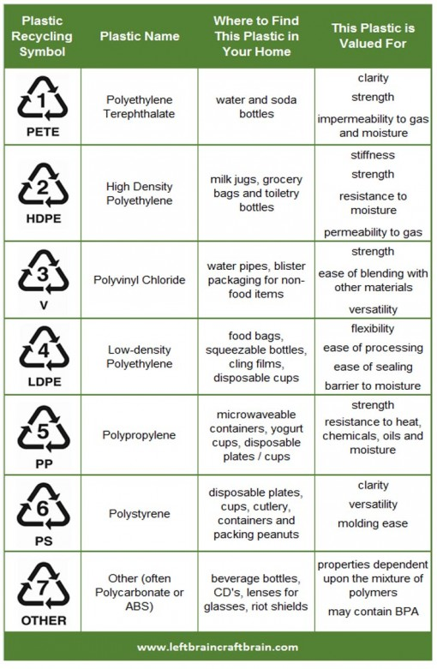

To Do:
- See if you can find one of each type of plastic in your home!
- Create a Compare/Contrast chart where you chart the similarities and differences between the different types. For instance, describe their appearance, strength, durability, their purpose/use
- Design an experiment where you test the different strength and durability capabilities for each type (or even just several different types). For instance, how many books can I stack on top of a pop bottle before it gets crushed; how many can I stack on top of a coffee contained or a piece of Tupperware before it gets crushed, etc. Or, how long will hot water stay hot in a number 1 versus a number 3, etc. Remember to state your hypothesis (what you think will happen), as well as your results (what happened!)
A sample for Compare/Contract template has been provided in the link below, as well as a hypothesis template. Enjoy!
https://www.edrawsoft.com/compare-contrast-graphic-organizer.html
https://www.verywellmind.com/what-is-a-hypothesis-2795239

Social Studies and Earth Day!
Choose one of these little-known environmental issues to research, answer the following questions in your Science Journal (if you have one! If not, use paper or start a Science Journal of your own to use for the rest of the year!)
- The use of microbeads in facial cleansers and their inability to break down in the environment
- The use of glitter in craft projects, and their inability to break down in the environment
- Plastic coffee lids and their abundance in our road-side ditches.
Use the information you gathered to create a poster that answers these questions while raising awareness about the issue.
- What is the problem?
Example: Plastic microbeads from face washes don’t get filtered out by water treatment plants and end up in rivers and the oceans.
- Why is it a problem?
Example: Animals that are filter feeders, like clams and oysters, accidentally consume the microbeads. Other animals may mistake the microplastics for food and eat them. The animals can’t digest the plastics and eventually die.
- Who is it a problem for? (Who would use your solution?)
Example: Companies that make face washes with microbeads.
- What is the desired outcome of your engineered solution? What would success look like?
Example: The outcome would be an environmentally safe alternative for microbeads in facial cleansers.
2. Using the answers to their questions, have students write their problem statement on the bottom of page 9 in their notebooks. They can use the following sentence frame as a guide: “______ needs a way to ______ so that ______.”
(Example: Companies that produce face washes with microbeads need a way to make their products with an environmentally-safe material so that microbeads don’t wind up in the rivers and oceans.)

Numeracy – Please aim to work a minimum of 2 hours daily in total for all subjects (not two hours EACH, but in total).

Here is the link to an on-line math workbook that is also a PDF file, meaning you can print it off if you have access to a printer. There is lots of flexibility here since you can pick and choose the topic each day, and a brief explanation is included with each new skill.

http://www.mathematicshed.com/uploads/1/2/5/7/12572836/decimalwordprobsgood.pdf

For further on-line worksheets, check out:https://www.dadsworksheets.com/worksheets/earth-day.html

Take care and be safe! Feel free to email me for feedback or just to check in! These are trying times, but as Martin Luther King Jr. Said, “we shall overcome!”

