Provincial Elementary Drama Festival
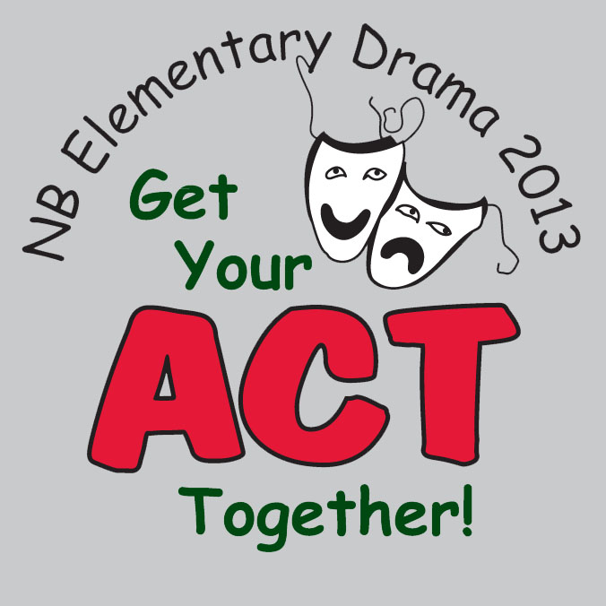
Thursday, April 25

9:30-10:00 Registration

10:00-10:30 Opening Ceremonies

10:30-11:30 Nackawic Elementary

11:30-12:30 Lunch Break

12:30-1:30 Hartland Community School
1:30-2:30 Southern Carleton Elementary
2:30-3:30 Florenceville Elementary

3:30-4:30 Workshops

4:30-5:00 Closing Ceremonies /Award Presentations

Friday, April 26

9:30-10:00 Registration

10:00-10:30 Opening Ceremonies

10:30-11:30 Debec Elementary

11:30-12:30 Lunch Break

12:30-1:30 Bristol Elementary
1:30-2:30 Woodstock Centennial
2:30-3:30 Bath Elementary

3:30-4:30 Workshops

4:30-5:00 Closing Ceremonies /Award Presentations

