### Burton School

Burton, NB

April 2018

Burton School Newsletter

April 2018

**V**

School News



Student Recognition 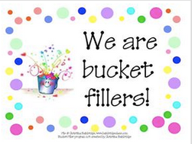

March’s winners won’t be revealed until this Friday. Be sure to look for March and April’s winners next month.

Our ceremony for April will be held Friday April 27th at 11:15am.

The theme for the month is good listening skills.

## French Cultural Afternoon

In grade K-2, the children are introduced to the French language through various experiences in their classrooms every week. We wish to celebrate this with a French cultural afternoon on April 8th. One of the parents, Mrs. Fournier has volunteered to make a traditional Francophone meal and read and sing traditional French songs to the children. We will be having pea soup, sandwiches on croissants, and for dessert, poudding chômeur. We appreciate the time and energy Mrs. Fournier is taking with this event! We would also like some volunteers who are available to come in to help and prepare the meal. If you speak French, it would be wonderful to expose the children to a different language and get them to practice a few words as well. Just let the office or myself know if you are available.

Dates of Interest

April 2- Easter Monday

April 6- 11:15 am- Recognition Ceremony

April 9- French Cultural Afternoon

April 11 – Report Cards Home

April 12- Parent Teacher Interviews 3:00- 6:00 pm

April 13- **NO SCHOOL FOR STUDENTS**

Parent- Teacher Interview 9:00-11:30 pm Professional Learning for teachers in PM

April 17- TNB- Manxmouse

April 24- no school for students in PM / Professional Learning for Staff

April 27 – Pre- Kindergarten Activity Afternoon 1:00-2:00 pm

April 27- Recognition Assembly 11:15 am

Report Cards 

Report Cards go home on Wednesday of next week, April 11th. You will note that they are the second of three progress reports you will be receiving this year. Teachers will be making appointments with parents **for Thursday evening, April 12th** between **3:00-6:00 pm and Friday morning April 13th from 9-11:30am.** We hope that you can come in to discuss your child’s progress. If these times are not convenient feel free to discuss with your child’s teacher an alternate time.

**Next Year** 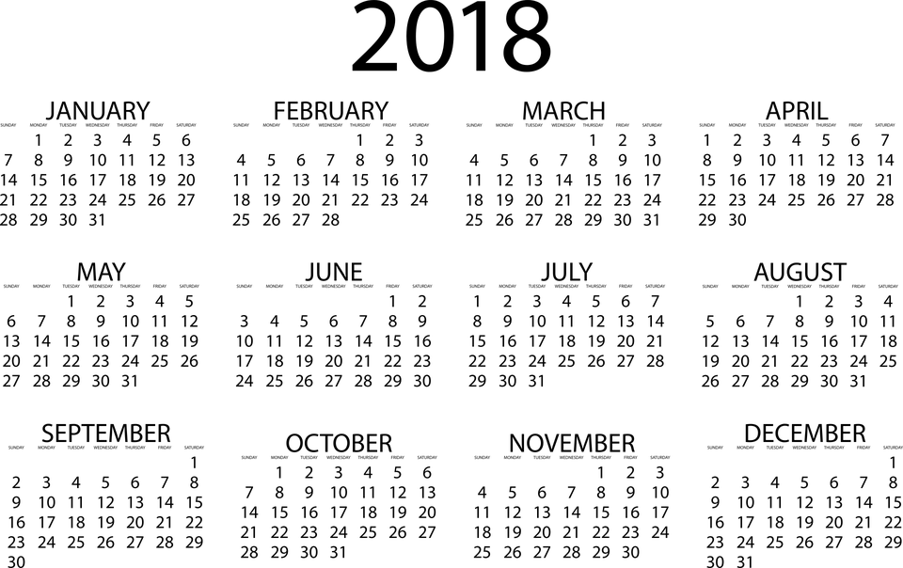

Although it sounds early, we are beginning to prepare for next years’ classes already. If you already know you will be leaving us (other than grade 2) could you please send us a note or jot in the agenda advising us of this. Thanks for your help.

*Did You Know?*

* That we collected over a hundred cans of food for the SPCA and the staff raised $120?
* We are able to continue providing eggs at recess, thanks to donations from the Egg Marketing Board!
* Our district literacy lead, Heather Murphy, will visit us in April and work with our staff and students?

#### Grade Two

**Literacy**

* Daily Five and Café
* Concepts / Vocabulary: comprehension, fluency, expression, strategies
* Writing – lengthening of stories, using Million Dollar Words

**Numeracy**

* Ordinal Numbers up to the tenth, compare and order numbers to 100, place value to 100, revisit addition and subtraction
* Concepts / Vocabulary: ordinal, order, greatest, least, compare

**You and Your World**

* Continue with Environment, Earth Day

**Principal’s Corner**

In the early grades it is important to focus on developing reading, writing and math skills. Much of our work looks at strategies that improve these areas. Lately we have worked with the math and literacy leads in our district on teaching techniques which can also effect student achievement. .

Another area that is important is exposing childrn to other areas such as singing, art and drama so childrn can expand areas of exposure. This is the rational for clusters, the play we just presented and exposing students to professional productions that are available. Many of our children have not had a chance to attend a production at the playhouse in Fredericton. We are going to take the students there Tuesday, April 17th tp see the play the Manx Mouse. There will be no cost to the students as we will pay the entrance with the monies raised from the community bottle recyclying. I have applied for a grant to cover most of the bussing cost.

Working together with parents and the community gives students an opportunity to have the best education possible. We thank you for your support always, whether it be doing homework to support your child’s learning or coming to see the work they have done in clusters and plays. It takes a community to raise a child with a love of learning who has the skills necessary to thrive in this world.

.

.

# Kindergarten

Literacy

* Students will continue to work on adding details and punctuation to their writing
* We will continue to work on using the reading strategy “stretchy snake” to sound words out
* Numeracy
* Kindergarten students will be learning to use direct comparison to compare 2 objects based on a single attribute (length, mass or volume)

You and Your World

* We will continue to learn about the 5 Senses

#### Grade One

**Literacy**

* We are continuing to focus on revising our writing piece, especially in the areas of conventions (ie; punctuation and upper case letters).
* In Daily 5, we will continue to work on individual reading goals such as comprehension, fluency and looking for "chunks" or known parts of a word to figure out unknown words.

**Numeracy:**

* Completing unit on addition with answer up to 12 and the corresponding subtraction facts.
* Say numbers to 100, forwards, backwards, counting by 5’s. 10’s
* Mental Math

**You and Your World:**

* Healthy Living, Environment

#### x