We will be travelling to King’s Arrow Arena for skating this month January 18th. Please dress your child appropriately as the rink may be cool. Of course children need a CSA approved helmet and skates. Parents are welcome to join us there at 9:10 AM.

* January 8th- students return
* January 15th- 6:00 pm Home and School Meeting/ 7:00 pm PSSC meeting
* January 18th - skating King’s Arrow Arena- 9:15-10:15 am
* February 1st- skating King’s Arrow Arena- 9:15-10:15 am
* February 2nd- student recognition assembly at 11:15 am

**Grow Tower**



The school has recently purchased an indoor grow tower. This is a unit where we can grow seeds indoors without soil. We are excited about letting children experience growing food and then ultimately eating what they have worked to grow. We will keep you informed about our progress.

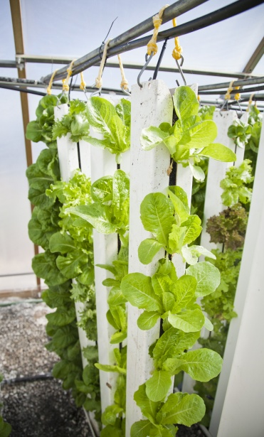

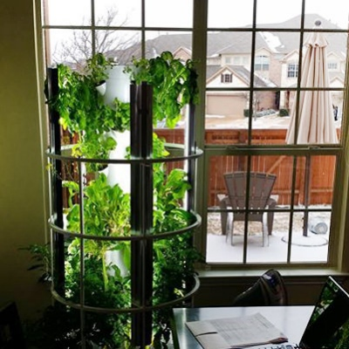

up updated with the progress in this area. 



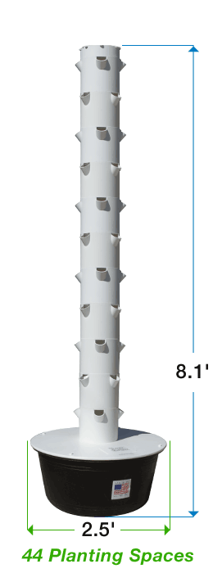

## Dates of Interest

Student Recognition

Congratulations to the following students who were recognized during December’s assembly for their “bucket filling” behaviour:

Kindergarten: Brayden Cavanagh

Grade 1: Arthur Durocher

Grade 2: Evan Layton

Phys Ed: Brady Merrithew, Landen Sarty, Maggie Alexander

Principal’s Choice: Joseph Persico

For January’s assembly we will be having the kindergarten class doing a presentation. The assembly will be held on **Friday, February 2nd at 11:15 pm** in the gym.

Our theme for January will be ‘Common Sense’.

**PSSC / Home and School**

The next Home and School meeting will be January 15th at 6:00 pm followed by PSSC at 7:00 pm. Parents are always welcome to attend.

Hot lunch will begin again next week. Forms will go home with your child today and are to be returned Friday morning. Please note late orders cannot be accepted but we will accept phone calls if your child is not at school Friday. Unfortunately refunds cannot be given but feel free to ask that their hot lunch be sent home the next day.

If you would like to volunteer to help with hot lunch, we are in need of help. If you are interested in picking up pizza Tuesday or counting hot lunch money Friday morning, please contact the school and let us know.

**Hot Lunch**

Skating

School News

January 2018



### Burton School

Burton, NB

January 2018

# Kindergarten

* All letters and their corresponding sounds have now been introduced. This month we will be practicing and I will be assessing the students.
* The reading strategies “Eagle Eye” (Look at the picture) and “Lips the Fish” (Look at the word and get your lips ready to say the first sound) will be reviewed and practiced.
* We will continue to work on sight word recognition.
* Students will continue to work on writing a sentence independently. We will practice leaving spaces between words, spelling some simple sight words correctly and using “letter writing” (writing words independently by writing the letter you hear in a word) to spell other words.

**Numeracy**

* We will continue to explore numbers, with a focus on numbers 6-10.
* Math Stations are being introduced to allow for individualized small group instruction.

**You and Your World**

#### We will be learning about healthy lifestyles

#### Grade One

**Literacy**

❖  Reading: students will continue to meet with me weekly and work on the strategies they need to become better readers.

❖  Writing: we will continue to work on personal writing goals ( sight words, details, etc...) as well as we will be beginning our "Writing For Readers" unit, where we fix up our writing and start to be more conscious of the people we are writing for.

❖  We will continue to work on learning sight words, word families and further develop phonic sounds.

**Numeracy**

* Counting to 20 and comparing the sets
* Addition and Subtraction to 12

**Concepts: Addition, number sentence, doubles, subtract, mental math**

**You and Your World**

* Healthy Lifestyles

#### Grade Two

**Literacy**

❖  Daily Five and Cafe

❖  Concepts / Vocabulary: comprehension, fluency, expression, strategies

❖  Writing

**Concepts / Vocabulary: punctuation, spacing, million dollar words, details, lengthening of stories**

**Numeracy**

❖  Addition and subtraction to 18

**Concepts / Vocabulary: addition, subtraction, sum, counting on, difference, equal, unequal, missing part, order, addition and subtraction sentences, compare, doubles, near doubles, even and odd numbers, mental math**

**You and Your World**

❖  Technology, Economics, Clusters

|  |
| --- |
| cid:image001.png@01D37A4A.86A0CC90  **The Integrated service Delivery – Child and Youth Team is available at the Burton Elementary School.** **Not sure where to turn? Need support now?**  Government departments, schools, community agencies and service-providers in New Brunswick have come together to help children and youth who have emotional, behavioural, mental health or addiction needs.  **What is Integrated Service Delivery (ISD)?**  The Government of New Brunswick has adopted a child and youth-centered ISD framework, to improve services and programs for children and youth up to the age of 21.  Services are available in schools and other community settings. They are provided in places that are comfortable for children, youth and families, school and service-providers from the community.  If you would like more information come to the Wellness Night at Burton Elementary School on **Monday, February 12, 2017** the ISD C&Y Team will participate in the **Wellness Night at Burton Elementary School from 6:00 - 7:00 PM**. Come and learn about the services offered in the Burton community.  **How to find a CY team in your community?**  You can reach a CY team through your school or at an Addiction and Mental Health Services regional office at 506-453-2132 |

Burton School Newsletter Page 2