# Student Recognition

Every month we try to do a Student Recognition Assembly to recognize student achievements throughout the month.

November’s Assembly will be held on Monday, November 30th at 11:10am.

**Our theme for November will be “COOPERATION”!** This month our theme is cooperation. Cooperating is about working together and helping others. When students cooperate, they have more positive social interactions and are better able to make and keep friends. Cooperation is a big word and a complicated skill.

How can parents help?

**Break this complex skill down into smaller, easier to understand steps**. For example, you could tell your child cooperation means 1) taking turns, 2) working together, and 3) sharing.

**Model cooperation skills at home and with friends.**

**Role-play how to cooperate**

**Use specific praise to encourage children’s efforts to cooperate.-** This might sound something like “Nice job taking turns and cooperating with your sister” or “I really appreciate how you are working together to finish this puzzle with your friends.”

Remember, your child’s cooperation skills do not have to be perfect before you provide some praise. Teaching children how to cooperate early really sets them up for long-term success with friendships and more!

**Kindergarten Registration**

Even though the official Kindergarten Registration week is over, you can still register your child for kindergarten online. We encourage parents/guardians to register online as much as possible.

You can do so at the following link: <https://secure1.nbed.nb.ca/sites/ASD-W/kindergarten/Pages/default.aspx>

When instructed to do so, please bring along your Birth Certificate, Medicare card, and Immunization records. If you know of a neighbor with children entering school next year, please pass along this information.

Time is flying! October was a great month at Burton, but November is shaping up to be just as wonderful. We are starting the month off with a field trip to Science East and ending the month with a visit from a dietician to help us with our Healthy Minds challenge.

This month is also very important for a reason very close to my heart. November 11 is Remembrance Day. With all the restrictions in place because of COVID we are unable to mark the day in the usual ways. However, as a grandchild of a veteran and a friend of a fallen soldier, it is important to me that students still learn about and participate in Remembrance Day activities that are meaningful and connected to them.

On November 10th students will view pre-recorded service that includes all the elements of the traditional service. Following the viewing, classes will place wreaths at a cenotaph by our school sign. Our hope is that the students gain a sense of the importance of the day and feel a sense of pride in showing their community their gratitude for those who serve.

On a final note, a special thank you to our very own Mrs. Morabito for her service and for arranging a special cenotaph for our school.

# School Photos

Harvey’s will be here at the school on

**Friday, November 27th,** at 8:30am to do

student **RE-TAKE photos** Should you need

a retake or were absent the day they were here in October, please make sure your child’s teacher knows so they can do retakes.



# Principal’s Message

October Newsletter

banner with apples and crayons

### Burton School

Burton, NB

November 2020

School News

# This Month’s Highlights

* Nov 2- Recognition Ceremony- 11:10 am
* Nov 2 – PSSC & Home and School 6:00 pm
* Nov 9 – Field Trip: Science East
* Nov 10- Remembrance Day Observance, 10:30am
* Nov 11 – No School: Remembrance Day
* Nov 20 – No School: Staff PD Day
* Nov 27 – Photo Retakes, 8:30am
* Nov 30- Recognition Ceremony- 11:10 am

**REMINDER:** Students will be departing on **Friday’s at 11:45am**. Please be at the school by then, or a few minutes before, if you will be picking your child up instead of them going on the bus. Please remember **NOT** to **block** the **bus loading zone**, and to **drive with care** while on school grounds.

**Hot Lunch Reminder:** Remember to have your orders into School CashOnline by 11:59pm the Thursday **before** (ex: if ordering for Nov 17th, need to have order in by 11:59pm on Nov 12th).

On Wednesday, **October 14th,** we all headed to the Gilbert Apple Orchard to pick apples and tour the apple orchard, have a scavenger hunt and saw the cows that had just returned from their “island vacation”. A big thank you goes out to Melisa (Missy) and Malcolm Gilbert for their wonderful support of our school in allowing us to visit their farm.

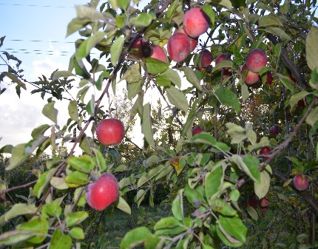

# Grow Tower

**Tower Garden: Grade 1**

Grade 1 students will be working on a collaborative project that will practice literacy, numeracy, and exploration skills in the upcoming weeks.

Students are learning about how to grow plants using an indoor Tower Garden.

They will discuss and decide the best plant choices for the group and will learn the names of each type of plant.

Students will be recording observations and completing descriptive writing tasks, along with collaborating on a recording station designed to share our progress.

We are excited to commence this project and we look forward to learning together.

# Home and School/PSSC

# Science East Field Trip

Students will be travelling to Science East on Monday, November 9th to participate in workshops that focus on patterns, sequencing and computational thinking, using Code-a-Pillars, or Botley. Students will also explore the regular exhibits.

# Healthy Schools Challenge

From November 23-27, students and staff will be participating in our first Heart Healthy Schools Challenge, which is the Fruit and Veggie Challenge. We will learn about the importance of eating 5 servings of fruit and veggies each day and will also have an opportunity to enjoy a variety of fruits. **Please watch for a Fruit/Veggie Journal coming home with your child on the 23rd.**

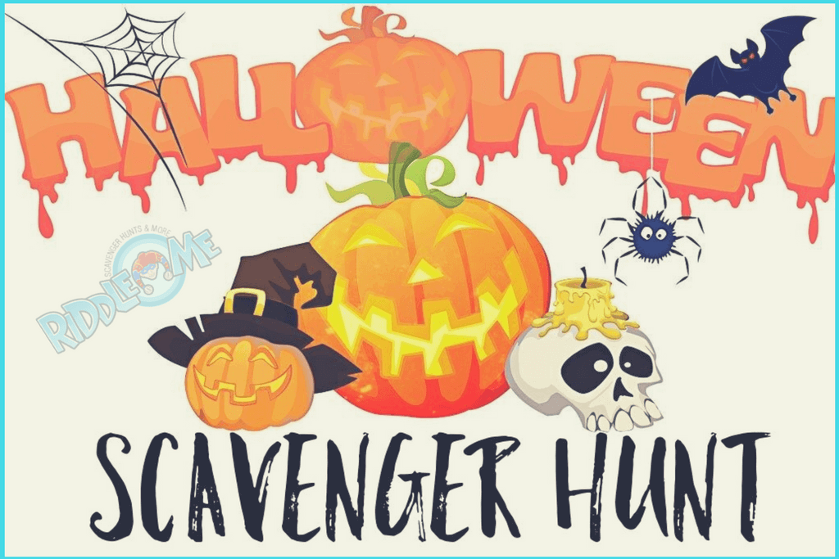

Thank you to the Home and School for hosting the Halloween Scavenger Hunt for our students! They had a lot of fun searching for the items and got some fresh air at the same time!!

## Apple Picking

Burton School Newsletter Page 2