# Student Recognition

Congratulations to the following students who were recognized during September assembly for their “bucket filling” behaviour:

Kindergarten: Sierra Dessouroux

Grade 1: Arthur Durocher

Grade 2: Landon Quinn

Phys Ed: Justine Ford, Emily Gauthier, Landon Quinn

Principal’s Choice: Ava Gouthro

October’s Assembly will be held on Friday, October 27th at 11:15 am.

Our theme for October will be co-operation.

# Home and School/PSSC

Our first meeting will be October 16, 2017. At 6:00 pm we will meet for Home and School and 7:00 pm we meet for PSSC. At the Home and School meeting, we will discuss hot lunch and volunteers as well as a Halloween Fun Night. New members are also welcome to join. Our first PSSC meeting will be a discussion of what the purpose of this group is, as well as reviewing a proposal to the DEC on Thursday, October 19th.

We have had an awesome start to the school year and already the school year is flying by! It seems we have barely begun and October is already here with talk of Halloween, Remembrance Day, and Christmas! We have had many people indicate they would volunteer and we thank them as they offer support as our hot lunch program begins, and we plan for the many things that make Burton Elementary a wonderful school!

# School Photos

Harvey’s will be coming to the school the morning of October 20st to do students pictures. They will be starting first thing in the morning so please try to ensure your child arrives on time.

**Kindergarten Registration**

On October 10-13th, kindergarten registration for next year will be occurring at the school. From 8:30- 4:00 pm parents are invited to come to the school to register any children they have entering kindergarten next year. Please bring along your Birth Certificate, Medicare card, and Immunization records.



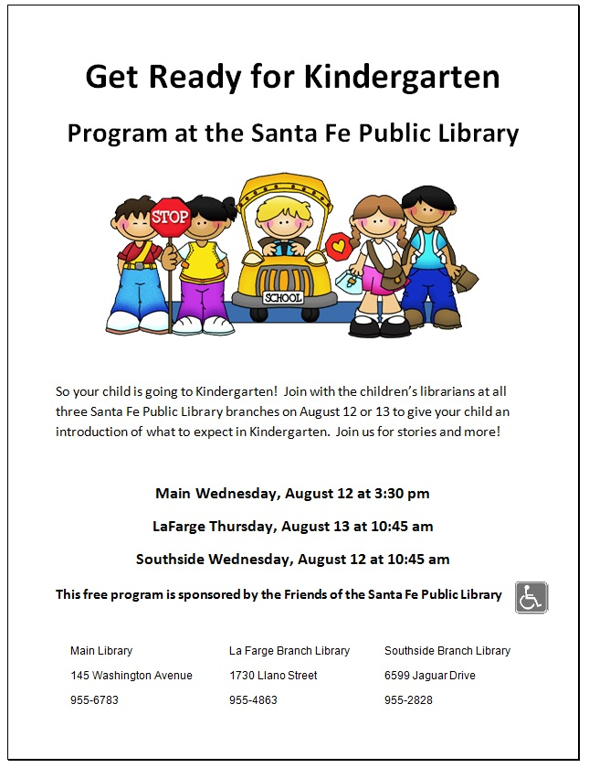

Safety week has been scheduled for October 16th - 20th. We will be conducting fire drills, lockdown procedures, bus safety and talking about school evacuation. Each classroom will be going over safety procedures and guidelines this week. A more detailed note will come home at the beginning of that week to explain the daily plan to practice the protocols. We recognize that some children may be frightened but we will reassure them it is only practice so we know what to do in the event that these protocols are necessary.

# Safety Week

# Principal’s Message

October Newsletter

banner with apples and crayons

### Burton School

Burton, NB

October 2017

School News

On Wednesday, October 5th we will be heading to the Gilbert Apple Orchard to pick apples and tour the apple orchard. We will be leaving after recess at approximately 11:15 am and walking across to the orchard where we will have the tour followed by a picnic lunch. Students should be dressed appropriately. We will be sending a small amount of apples home with the children that night. Melissa Ashburne has kindly agreed to do the tour for free. We will be providing a picnic lunch at the orchard for free that day. There will be cheese and crackers, veggies, milk or juice, piece of fruit and yogurt tubes for lunch. Please fill in the permission slip attached and return to your child’s teacher by Wednesday.

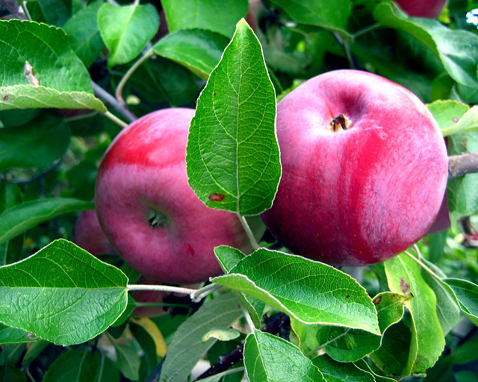

# Eggs

As your child may have informed you, at recess time we have hard boiled eggs donated by the Oromocto Food Bank. Any child who wishes to have an egg is welcome to go to the office and receive a warmed egg at this time. Thank you to the food bank for doing this wonderful service!

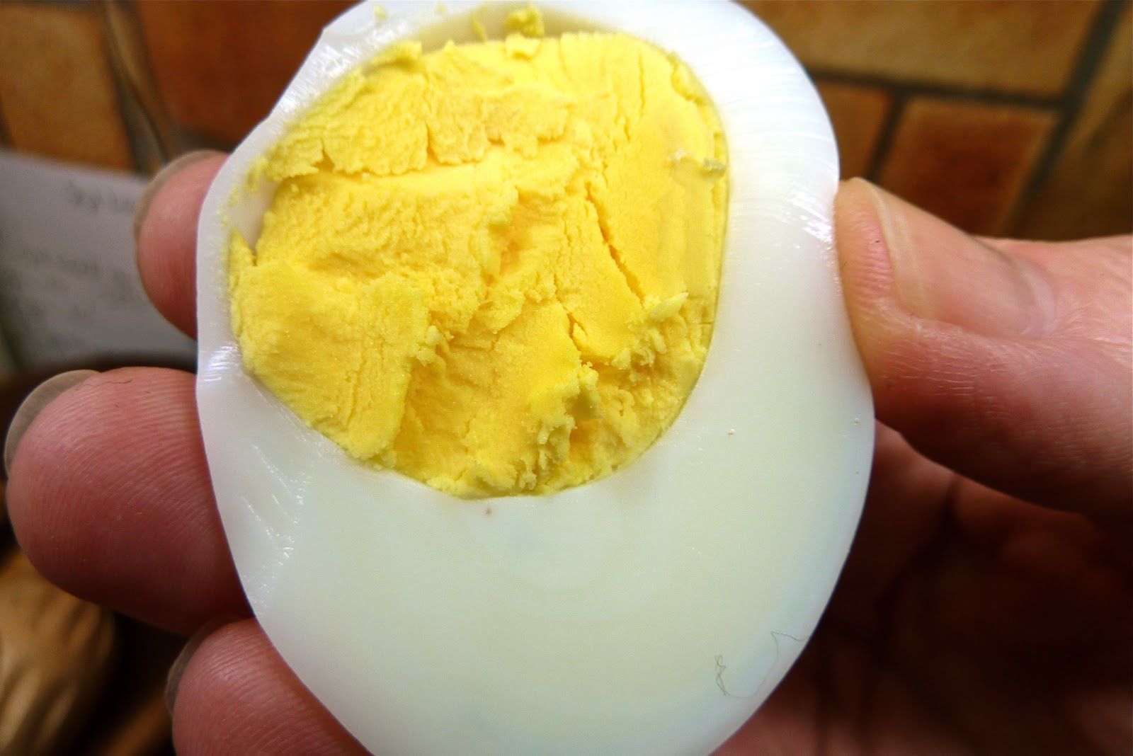

## Apple Picking

# This Month’s Highlights

* Oct. 5- Apple Picking- - Gilbert Farms
* Oct. 9- Thanksgiving- No School
* Oct. 16- Home and School- 6:00 pm

PSSC- 7:00 pm

* Oct. 20- School Photos
* Oct. 24- early dismissal for students (professional learning for teachers)
* Oct. 27- Recognition Ceremony- 11:15 am
* Oct. 31 – class Halloween parties

## Terry Fox Fundraiser

We would like to thank everyone who participated in the Terry Fox run last Thursday.

We were able to get outside and walk a couple of times around the building. If you still wish to make a donation please send it to the school this week as we will total the donations and send a cheque this Friday.

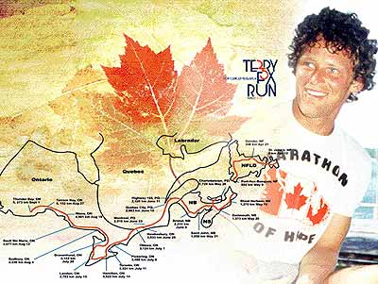

Burton School Newsletter Page 2