New members are welcome to join. Thank you to all that support and assist our school. Please feel free to join **the Burton Home and School Facebook page** to keep updated on events and activities! The first virtual meeting will be October12th. Please contact the office at (506) 357-4074 if you would like to attend.

# Student Recognition

We recognize student achievements throughout the month.

October’s Assembly will be held on Friday, October 29th, at 11:10am.

September’s students that were recognized for **‘Off to a Good Start’** were:

Grade K: Brooke Denyes

Grade 1: Alexander Paish

Grade 2: Avery Cavanagh

Principal Award: Abel Melanson

Congratulations to all the winners!

**Our theme for October will be “Gratitude”!**

Safety week has been scheduled for **October 17th -23rd**. We will be conducting fire drills, lockdown procedures, bus safety and talking about school evacuation. Each classroom will be going over safety procedures and guidelines this week. A more detailed note will come home at the beginning of that week to explain the daily plan to practice the protocols. We recognize that some children may be frightened but we will reassure them it is only practice, so we know what to do in the event that these protocols are necessary.

# Safety Week

# Home and School/PSSC



Dear Families,

Welcome back to another year at Burton Elementary School! Students are settling into routines very nicely. Students have been learning and practicing the behaviors from our code of conduct. If you haven’t already, you can check it out in the student agenda.

As you may have noticed already, we have started Burton Praise slips to recognize the positive behavior we see in our students. We have also introduced the “Burton Bump” fist bump as a safe way to give each other encouragement. We will continue to highlight a character development theme each month and recognize students who are exemplars of those themes. September was “Off to a Good Start”. In October students will be learning about the power of gratitude.

On behalf of the staff, I thank you for helping make the start-up run smoothly for your children and we appreciate your continued support. If you are looking to get more involved with school activities, you can contact Mrs. Morabito. We look forward to another wonderful year with our Burton Stars!

# School Photos

Harvey’s will be here at the school on **Friday, October 8th,** at 8:30am to do student pictures. Should you need a retake or are absent that day please make sure your child’s teacher knows so they can do retakes.

**Kindergarten Registration**

From **October** **12**th**-15th**, kindergarten registration for next year will be occurring at the school. Thisyear, due to Covid-19, the process will be different as we encourage parents/guardians to **register online as much as possible.**

You can do so at the following link: [**https://secure1.nbed.nb.ca/sites/ASD-W/kindergarten/Pages/default.aspx**](https://secure1.nbed.nb.ca/sites/ASD-W/kindergarten/Pages/default.aspx)

When instructed to do so, please bring along your Birth Certificate, Medicare card, and Immunization records. If you know of a neighbor with children entering school next year, please pass along this information.

# Principal’s Message

October Newsletter

banner with apples and crayons

School News

**REMINDER:** The bus will be departing on **Friday’s at 11:45am**. If you will be picking your child up instead of them going on the bus, please do not enter the bus lane until the bus has departed.

**Hot Lunch:** We hope to start the Hot Lunch program once we return from the Thanksgiving weekend (starting October 12th). Looking at having Subway and Pizza Delight again, plus our parent volunteers will be making yummy Grilled Cheese Sandwiches again, with cucumber slices on the side. Parents looking to volunteer for meal pick-ups and making sandwiches are always welcome. Please contact the school for more info on how to be a volunteer!

# School Staff 2021-2022

Principal/Resource/ Mrs. Melanie Charlton

Guidance/Gym:

Kindergarten : Mrs. Krista Appleyard

Grade 1: Mrs. Wendy Wells

Grade 2: Mrs. Tanya Smith

Gym Teacher (Mondays): Mr. Brad Kersing

Administrative Assistant II: Mrs. Margaret Morabito

Educational Assistant: Ms. Verna Bedford

Educational Assistant: Mrs. Johanna McIntyre

Educational Assistant: Mrs. Kimberly Bourque

Bus Driver: Danny Bourgeois

Custodian: Mr. Jeff Brown

# This Month’s Highlights

* Oct. 11- Thanksgiving- No School
* Oct 12-15- registration for kindergarten next year
* Oct. 3-9 – Fire Prevention Week
* Oct. 17-23– Safe Schools Week
* Oct 29 - Recognition Ceremony- 11:10 am

On Tuesday, **October 5th** we are going to the Gilbert Apple Orchard to pick apples and tour the apple orchard. The students will leave after recess and head to the orchard, have a tour, wagon ride and scavenger hunt. Due to Covid-19 regulations, we are not able to provide a lunch this year, so the students MUST BRING their own lunch with them. Students will each bring a 5lb bag of apples home with them. This can be purchased on **SchoolCashOnline.** Thank you to Gilbert’s Farm and Melissa and Malcolm Gilbert!

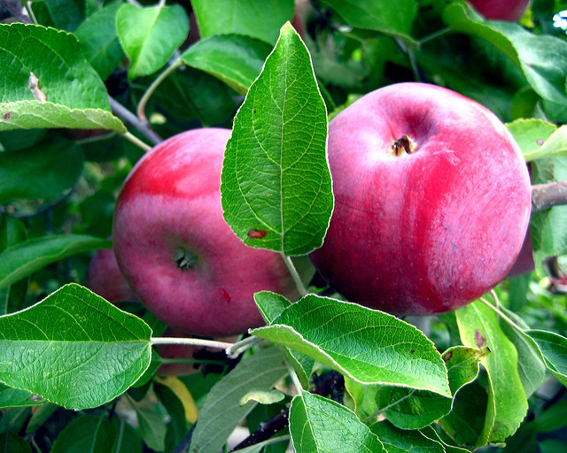

# Breakfast Program

As your child may have informed you, we have started a breakfast program this year. We offer hard-boiled eggs donated by the Oromocto Food Bank. The food bank provides the eggs for us for free and we truly appreciate it. We also offer Multi-grain Cheerios (dry) and apples as a breakfast snack, Any family wishing to donate fruit for this program throughout the year, we would gladly accept.

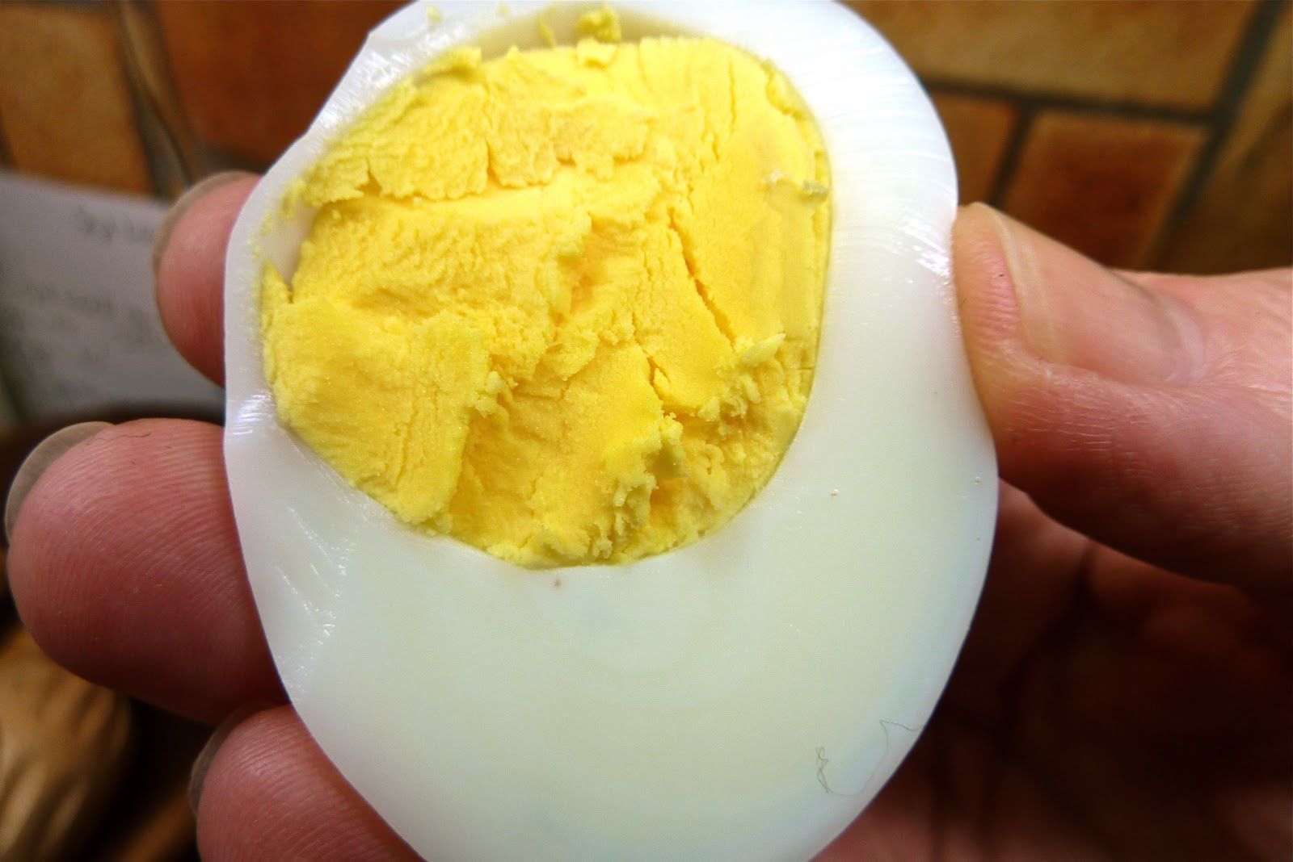

## Apple Picking

Burton School Newsletter Page 2