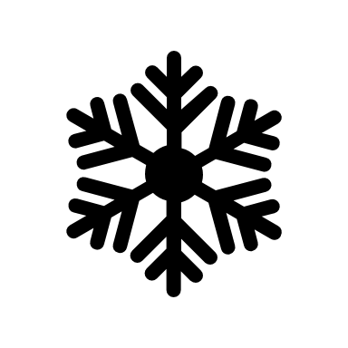

November Morning Announcements Grades 6-12
Winter Safety

- Winter is just around the corner. Stay safe this winter by keeping track of the weather. If temperatures fall below – 25 C (-13 F) stay indoors as exposed skin can freeze within a few minutes.

- Winter is coming! Stay safe this winter by bundling up. Dress in layers to stay warm and dry. A single pair of wool blend socks is better to keep feet dry and avoid restriction of blood and air flow to the feet.

- Winter sports like sliding, skating and skiing can be lots of fun. Remember to Stay safe this winter by wearing your safety gear. Helmet use is recommended. Serious head injuries, like concussions, can be prevented with correct helmet use. Make sure your equipment is in good repair and properly fitted.

- Do you enjoy winter sports? Remember goggles, sun glasses and sun screen will help protect you when participating in winter activities. Make sure you are always prepared.

- Did you know that skating and pond hockey are popular winter sports? Stay safe this winter by checking the depth and quality of the ice of ponds, lakes, and rivers before crossing. Ice thickness should be approximately 20 cm (8 inches) for skating and 25 cm (10 inches) for snowmobiles. Obey all signs posted by ponds and lakes. Your safety matters!

